**DEWAN INSTITUTE OF MANAGEMENT STUDIES**



MAJOR PROJECT

ON

**“HOSTEL MANAGEMENT SYSTEM”**

Submitted in the partial fulfillment of the requirements for the award of the degree of

**MASTER OF COMPUTER APPLICATION (MCA)**

**Affiliated to**



**Dr.A.P.J.Abdul kalam Technical University,Lucknow**

**MCA – 2nd Year** I**Vth Semester**

**(Batch: 2022 – 2024)**

**SUBMITTED TO:-**

**MR. PAWAN GOEL SIR**

**(PROJECT CO-ORDINATOR)**

**SUBMITTED BY:-**

**Aman Yadav**

**(2200740140049)**



DEWAN INSTITUTE OF MANAGEMENT STUDIES

**ROLES and DECLARATION**

We hereby certify that this project titled **“HOSTEL MANAGEMENT SYSTEM”,** submitted to **DEWAN INSTITUTE OF MANAGEMENT STUDIES,Meerut** affiliated to **DR.A.P.J. University, Meerut** as a partial requirement for the award of the degree **“MASTER OF COMPUTER APPLICATION”** is an original work carried out by **AMAN YADAV** as a **PROGRAMMER & DESIGNER** **&DATA ANALYST & DESIGNER**  and **ARVIND** as a **TESTER** under the guidance of **Mr. PAWAN GOEL SIR Sir.**

**AMAN YADAV (Programmer& Designer)**

**Sign:-__________________**

**MCA IVth Semester**

**CONTENTS**

**1.INTRODUCTION**

**2.OBJECTIVES**

**3.SYSTEM SPECIFICATION**

1. **Requirement Analysis**
2. **SRS**
3. **Hardware and Software Requirements**

**4.TOOLS , PLATFORM AND LANGUAGE USED**

**5.SYSTEM DESIGN**

1. **Data Flow Diagrams**
2. **Design Phase**
3. **Form Layouts**

**6. Source Code**

**7. TESTING**

**8. IMPLEMENTATION and EVALUATION**

**9. Future Scope**

**10. BIBLIOGRAPHY**

**Introduction :-**

Hostel management system is a software system that is used to manage the operations of a hostel.It is used to maintaining various activities in the hostel.It is used to store the data about the students who live in the hostel and those employees who work in the hostel.This Project deals with the problems on managing a hostel that are carried out by manual entry of hostel data.

**Objective :-**

As the name specifies **“HOSTEL MANAGEMENT SYSTEM”** is software developed for managing various activities in the hostel. For the past few years the number of educational institutions is increasing rapidly. Thereby the number of hostels is also increasing for the accommodation of the students studying in this institution. And hence there is a lot of strain on the person who are running the hostel and software’s are not usually used in this context. This particular project deals with the problems on managing a hostel and avoids the problems which occur when carried manually.

This System can be used to assign rooms to students and manage them.It can be used to store the details of the students who currently living in the hostel and it also manage the Student rent and It can also be used to details of the employees who are working in the hostel like housekepping,cook etc.

We can improve the efficiency of the system, thus overcome the drawbacks of the existing hostel management system.Less human error, Strength and strain of manual labour can be reduced, High security, Data redundancy can be avoided to some extent, Data consistency, Easy to handle, Easy data updating, Easy record keeping can be maintained.

**Software Requirement Specification(SRS)**

The aim of the system is to develope **“Hostel MANAGEMENT** **SYSTEM”** software, which should automate the process to adding, storing, managing various entities of a hostel such as ROOMS, STUDENTS, EMPLOYEES as well as USERS using this system . The system is supposed to be used in a Hostel, which could be manually handled or a computerized one. Therefore, the proposed system must be able to function under both circumstances.

**The proposed system** is not a freeware and due to the usage of swings, becomes user interactive.

* The project demand a page of room, student and employee details that include:
* Employee’s and student’s personel detail.
* Room’s detail
* Employee’s salary student’s rent details.

***Software Requirements:***

* Front-End - JDK 8 or above.
* Back-End – MySQL.
* Operating System – Windows XP or above.
* IDE – IntelliJ IDEA

***Hardware Requirements:***

* Desktop PC or a Laptop
* Intel® CoreTM i3-6006U CPU @ 2.00GHz
* RAM - 4.00 GB
* 64-bit operating system, x64 based processor
* 1024 x 786 monitor resolution
* Keyboard and Mouse

**Feasibility Study**

Feasibility is the determination of whether or not a project is worth doing. The process followed in making this determination is called a feasibility study. This type of study determines if a project can and should be taken.

This project has also undertaken in the scope of feasibility study. As in the intercomel system there are so many deficiencies so to overcome from these deficiencies new computerized system required. But whether the new system is feasible in the realistic conditions or not for this purpose we have seen this project from different criteria’s. Many feasibility studies are necessary for both users and analysts.

The feasibility studies may be carried out in three phases:

(i) Technical Feasibility

(ii) Operational Feasibility

(iii) Economic Feasibility

**4.1 Technical Feasibility:**

During technical analysis the technical merits of the system concept are evaluated, at the same collecting additional information about performance, reliability, maintainability and produce-ability. In some cases, it also includes a limited amount of research and design.

Technical analysis begins with an assessment of the viable of the proposed system. What technologies are required to accomplish system function and performance? What new methods, algorithms or processes are required, and what is their development risk? How will these technologies affect Cost? The tools available for technical analysis are derived from mathematical modeling and optimization techniques, probability and statistics, queuing theory and control theory.

Technical Feasibility is frequently the most difficult area to assess at this stage of the product engineering process. Because objectives, functions and performance are somewhat hazy, anything seems possible if the “right” assumptions are made. It is essential that the process of analysis and definition to be conducted in parallel with an assessment of technical feasibility.

The considerations those are normally associated with technical feasibility Include:

**Development Risk*:*** can the system element to design so that necessary function and performance are achieved within the constraints uncovered during analysis?

**Resource Availability*:*** Are skilled staff available to develop the system element in question? Are other necessary resources (hardware and software) available to build the system?

**Technology:** Has the relevant technology progressed to a state that will support the system? The considerations that are normally associated with technical feasibility include development risk, resource availability and technology.

**4.2 Operational Feasibility:**

It is mainly related to human organizational and political aspects. The points to be considered are:

1. What changes will be brought with the system?

2. What organizational structures are disturbed?

3. What new skills will be required?

Do the existing staff members have these skills? If not, can they be trained in due course of time?

From Communication point of view it is operationally feasible because workload also reduced and they can utilize their valuable time in other value addition activities. Proposed System is beneficial only if that can be termed into information system that will meet the operating requirements of the organization. This test of feasibility asks if the system will work when it is developed and installed.

This is an important question that would help us perceive any resistance that might come from the end user community. Top management is committed to this project and is highly supportive. End user community has been suffering from the ill effects of the existing system and perceives that the proposed system would ease their work. There was no resistance from the employees for the proposed system as they were happy to learn that the manual system is being automated. End user community was tired getting a lashing from their management that they are not providing right and the accurate information. They have spent countless nights in re-working to provide accurate information. However, the problem of timeliness still persists. The users of the proposed system welcomed the change as they knew that the new system would bring right, useful information as and when required.

**4.3 Economical Feasibility:**

Economic analysis is the most frequently used method for evaluating the effectiveness of a candidate system. More commonly known as cost/benefit analysis, the procedure is to determine the benefits and savings that are expected from a candidate system and compare them with costs. If benefits outweigh costs, then the decision is made to design and implement the system. This is an ongoing effort that improves in accuracy at each phase of the system life cycle. So the Asterisk Server is an open source software so this is free of cost and this thing can be implemented on the existing resources so it is totally economic feasible.

**Data Flow Diagrams:-**

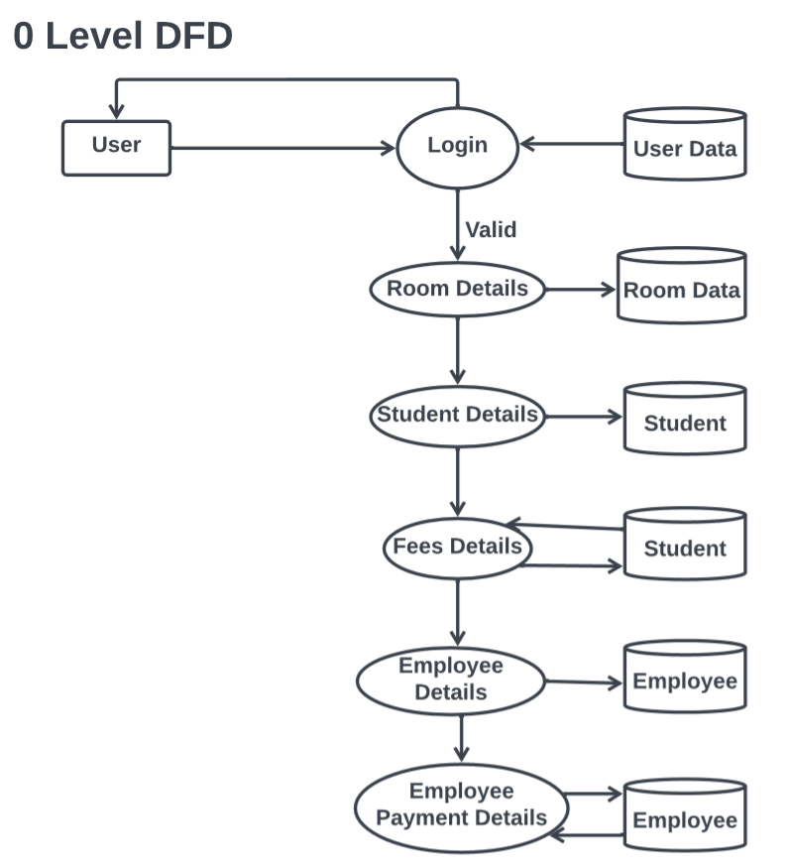

**1 Level DFDs:-**

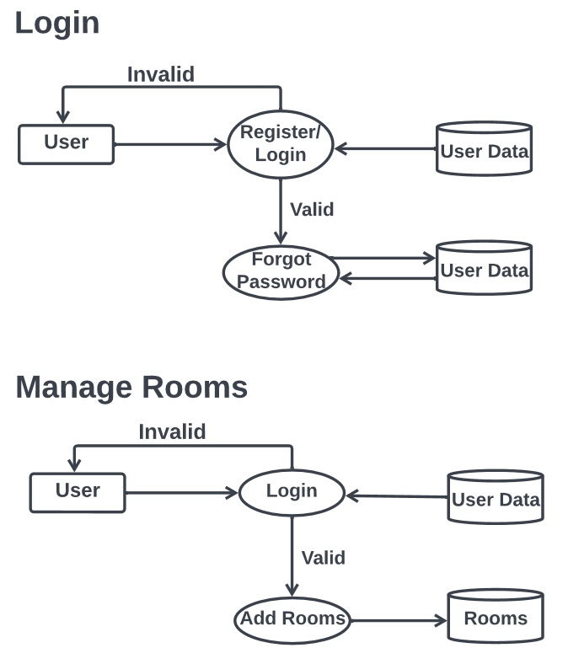

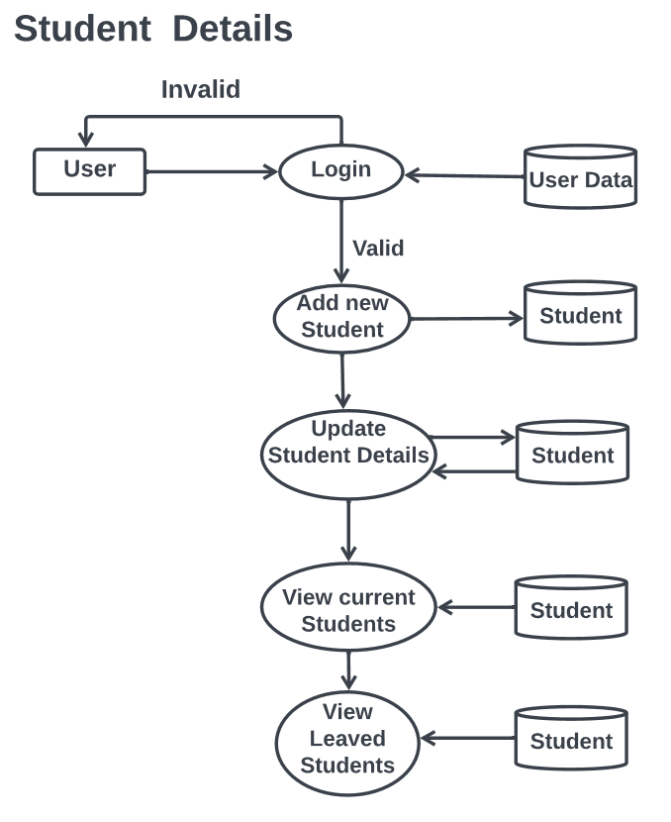

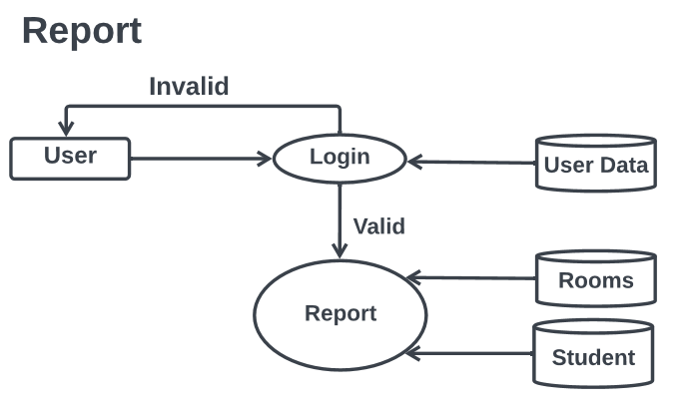

##### **Data Structure**

1. User Table

|  |  |  |  |
| --- | --- | --- | --- |
| **Sr.No** | **Field** | **Datatype** | **Constraints** |
| 1 | User_Name | Varchar(30) | Primary Key |
| 2 | Password | Varchar(45) | Not Null |
| 3 | Email | Varchar(45) | Not Null |
| 4 | Phone_No | Varchar(45) | Not Null |

##### Room

|  |  |  |  |
| --- | --- | --- | --- |
| **Sr.No** | **Field** | **Datatype** | **Constraints** |
| 1 | Room_no | int | Primary Key |
| 2 | Availability | Varchar(45) | Not null |
| 3 | Cleaning_status | Varchar(45) | Not Null |
| 4 | Price | int | Not null |
| 5 | TotalBeds | int | Not null |
| 6 | Block | Varchar(45) | Not null |

1. Student

|  |  |  |  |
| --- | --- | --- | --- |
| **Sr.No** | **Field** | **Datatype** | **Constraints** |
| 1 | Block | Varchar(20) | Not Null |
| 2 | Name | Varchar(45) | Not Null |
| 3 | Fname | Varchar(45) | Not Null |
| 4 | Mname | Varchar(45) | Not Null |
| 5 | MobileNo | Varchar(45) | Not Null |
| 6 | Aadhar | Varchar(45) | Primary Key |
| 7 | Address | Varchar(45) | Not Null |
| 8 | CollegeName | Varchar(45) | Not Null |
| 9 | RoomNumber | Varchar(45) | Foreign Key(Room) |
| 10 | Living Status | Varchar(45) | Not Null |
| 11 | Joining Date | Date | Not Null |

##### Employee

|  |  |  |  |
| --- | --- | --- | --- |
| **Sr.No** | **Field** | **Datatype** | **Constraints** |
| 1 | Block | Varchar(30) | Not Null |
| 2 | Name | Varchar(45) | Not Null |
| 3 | Fname | Varchar(45) | Not Null |
| 4 | Mname | Varchar(45) | Not Null |
| 5 | MobileNo | Varchar(45) | Not Null |
| 6 | Aadhar | Varchar(45) | Primary Key |
| 7 | Address | Varchar(45) | Not Null |
| 8 | Designation | Varchar(45) | Not Null |
| 9 | Working Status | Varchar(20) | Foreign Key(Room) |

1. Employee Payment

|  |  |  |  |
| --- | --- | --- | --- |
| **Sr.No** | **Field** | **Datatype** | **Constraints** |
| 1 | Block | Varchar(20) | Not Null |
| 2 | Aadhar No | Varchar(45) | Unique |
| 3 | Name | Varchar(45) | Not Null |
| 4 | Mobile No | Varchar(45) | Not Null |
| 5 | Designation | Varchar(45) | Not Null |
| 6 | Month | Varchar(45) | Not Null |
| 7 | Amount | Varchar(45) | Not Null |

1. Student Rent

|  |  |  |  |
| --- | --- | --- | --- |
| **Sr.No** | **Field** | **Datatype** | **Constraints** |
| 1 | Block | Varchar(20) | Not Null |
| 2 | Aadhar No | Varchar(45) | Unique |
| 3 | Name | Varchar(45) | Not Null |
| 4 | Mobile No | Varchar(45) | Not Null |
| 5 | Room No | Varchar(45) | Not Null |
| 6 | Month | Varchar(45) | Not Null |
| 7 | Amount | Varchar(45) | Not Null |

***Module Details:-***

1. No of Modules***:-***

The Project has been divided into Seven number of modules:-

1. Login Module
2. Manage Room Module
3. Student Details Module
4. Student Rent Module
5. Employee Details Module
6. Employee Payment Module
7. Report Module
8. Modules and their description***:-***
9. Process Logic of each Module:-
10. Login Module : This module is responsible to perform following task:-

* User Authentication
* Forget/Reset Password

1. Manage Room Module*:* This module is responsible to perform following task:-

* Add New Room
* Update Room

1. Student Details Module: This module is responsible to perform following task:-

* Add New Student
* Update/Delete Student Detail
* View Current Students
* View Leaved Students

1. Student Rent Module: This module is responsible to perform following task:-

* Student Rent Details

1. Employee Detail Module: This module is responsible to perform following task:-

* Add New Employee
* Update/Delete Employee Detail
* View Current Employees
* View Leaved Employees

1. Employee Payment Module: This module is responsible to perform following task:-

* Employee Payment Details

1. Report Module : This module is responsible to perform following task:-

* View student Report of Rent
* View Employee Report of payment

**Source Code**

**1. Login**

package Hostel;  
import javax.swing.ImageIcon;  
import javax.swing.*;  
import javax.swing.border.Border;  
import javax.swing.border.MatteBorder;  
import java.awt.*;  
import java.awt.event.*;  
import java.sql.Connection;  
import java.sql.PreparedStatement;  
import java.sql.ResultSet;  
import java.util.Random;  
  
public class Login extends JFrame implements ActionListener {  
 JFrame f1;  
 JLabel l1, l2;  
 JTextField t1;  
 JPasswordField p1;  
 JButton btn1,btn2;  
 Font ft1, ft2;  
 Connection con;  
 PreparedStatement ps;  
 ResultSet rs;  
 public Login() {  
 f1 = new JFrame("Login Page");  
  
 Border border = new MatteBorder(new Insets(0,0,1,0),Color.*BLACK*);  
 l1 = new JLabel("Username");  
 l2 = new JLabel("Password");  
 t1 = new JTextField("");  
 p1 = new JPasswordField("");  
 btn1 = new JButton("Login");  
 btn2 = new JButton("Forget Password");  
 ft1 = new Font("Monospaced", Font.*PLAIN*, 16);  
 ft2 = new Font("Monospaced", Font.*BOLD*, 20);  
 f1.setSize(500, 550);  
 f1.setLocationRelativeTo(null);  
 f1.setLayout(null);  
 f1.setDefaultCloseOperation(JFrame.*EXIT_ON_CLOSE*);  
 f1.setResizable(false);  
 f1.getContentPane().setBackground(Color.*WHITE*);  
 l1.setBounds(100, 150, 150, 20);  
 t1.setBounds(100, 165, 300, 30);  
 l2.setBounds(100, 212, 150, 20);  
 p1.setBounds(100, 225, 300, 30);  
 btn1.setBounds(185, 312, 120, 30);  
 btn2.setBounds(130, 382, 240, 30);  
 l1.setBackground(Color.*BLACK*);  
 l2.setBackground(Color.*BLACK*);  
 Random rand = new Random();  
 int[] arr={20,21,22,23,24};  
 int str = arr[rand.nextInt(arr.length)];  
 ImageIcon i1=new ImageIcon(ClassLoader.*getSystemResource*("Hostel/"+str+".jpeg"));  
 JLabel image=new JLabel(i1);  
 image.setBounds(0,0,500,550);  
 f1.add(image);  
 t1.setOpaque(false);  
 p1.setOpaque(false);  
 t1.setBorder(border);  
 p1.setBorder(border);  
 l1.setFont(ft1);  
 l2.setFont(ft1);  
 t1.setFont(ft2);  
 p1.setFont(ft2);  
 btn1.setFont(new Font("Monospace",Font.*BOLD*,22));  
 btn2.setFont(new Font("Monospace",Font.*BOLD*,22));  
 btn1.addActionListener(this);  
 btn2.addActionListener(this);  
 btn1.setCursor(Cursor.*getPredefinedCursor*(Cursor.*HAND_CURSOR*));  
 btn2.setCursor(Cursor.*getPredefinedCursor*(Cursor.*HAND_CURSOR*));  
 image.add(l1);  
 image.add(l2);  
 image.add(t1);  
 image.add(p1);  
 image.add(btn1);  
 image.add(btn2);  
 f1.setVisible(true);  
 }  
 public void actionPerformed(ActionEvent ae) {  
 if (ae.getSource() == btn1) {  
 String nm;  
 String pwd;  
 nm=t1.getText();  
 pwd=p1.getText();  
 if (nm.length()==0 && pwd.length()==0){  
 JOptionPane.*showMessageDialog*(null, "Please Enter Username and Password");  
 } else if (nm.length()==0) {  
 JOptionPane.*showMessageDialog*(null, "Please Enter Username");  
 } else if (pwd.length()==0) {  
 JOptionPane.*showMessageDialog*(null, "Please Enter Password");  
 }else {  
 try {  
 con = DBConnection.*createDBConnection*();  
 ps = con.prepareStatement("select * from user where User_Name=? and Password=?");  
 ps.setString(1, nm);  
 ps.setString(2, pwd);  
 rs = ps.executeQuery();  
 if (rs.next()) {  
 HomePage hp=new HomePage();  
 f1.dispose();  
 }  
 else  
 {  
 JOptionPane.*showMessageDialog*(null,"Invalid Username and Password");  
 }  
 } catch (Exception e) {  
 e.printStackTrace();  
 }}  
 }  
 else if (ae.getSource()==btn2)  
 {  
 ForgetPwd fpwd=new ForgetPwd();  
 f1.dispose();  
 }  
 }  
}

**2.** package Hostel;  
import javax.swing.*;  
import javax.swing.border.Border;  
import javax.swing.border.MatteBorder;  
import java.awt.*;  
import java.awt.event.ActionEvent;  
import java.awt.event.ActionListener;  
import java.awt.event.MouseAdapter;  
import java.awt.event.MouseEvent;  
import java.sql.*;  
public class ForgetPwd implements ActionListener {  
 JFrame f1;  
 JLabel l1,l2,l3,image,support;  
 JTextField t1;  
 JPasswordField p1,p2;  
 JButton b1,b2,Breach;  
 Font ft1,ft2;  
 Connection con;  
 PreparedStatement st;  
 ResultSet rs;  
 public ForgetPwd()  
 {  
 f1=new JFrame("Forget Password");  
 Border border = new MatteBorder(new Insets(0,0,1,0),Color.*BLACK*);  
 f1.setSize(600,450);  
 f1.setResizable(false);  
 f1.setLocationRelativeTo(null);  
 f1.setLayout(null);  
 f1.setDefaultCloseOperation(JFrame.*DISPOSE_ON_CLOSE*);  
 ft1=new Font("Monospaced",Font.*BOLD*,20);  
 ft2 = new Font("Monospaced", Font.*BOLD*, 17);  
 l1=new JLabel("User Name");  
 l1.setFont(ft1);  
 l1.setBounds(75,50,230,30);  
 t1=new JTextField();  
 t1.setFont(ft2);  
 t1.setBounds(280,50,140,30);  
 t1.setOpaque(false);  
 l2=new JLabel("New Password");  
 l2.setFont(ft1);  
 l2.setBounds(75,130,230,30);  
 p1=new JPasswordField();  
 p1.setFont(ft2);  
 p1.setBounds(280,130,140,30);  
 l3=new JLabel("Confirm Password");  
 l3.setFont(ft1);  
 l3.setBounds(75,210,230,30);  
 p2=new JPasswordField();  
 p2.setFont(ft2);  
 p2.setBounds(280,210,140,30);  
 p1.setOpaque(false);  
 p2.setOpaque(false);  
 b1=new JButton("Change");  
 b1.setFont(ft1);  
 b1.addActionListener(this);  
 b1.setBounds(75,300,150,40);  
 b2=new JButton("Close");  
 b2.setFont(ft1);  
 b2.addActionListener(this);  
 b2.setBounds(280,300,150,40);  
 Breach = new JButton("");  
 Breach.setBounds(585,410,30,30);  
 Breach.setForeground(Color.*BLUE*);  
 Breach.addActionListener(this);  
 Breach.setContentAreaFilled(false);  
 Breach.setOpaque(false);  
 Breach.setBorderPainted(false);  
 support =new JLabel("Forgot Username?");  
 support.setForeground(new Color(119,136,153));  
 support.addMouseListener(new MouseAdapter() {  
 @Override  
 public void mouseEntered(MouseEvent e) {  
 support.setForeground(Color.*BLUE*.darker());  
 }  
  
 });  
 support.addMouseListener(new MouseAdapter() {  
 @Override  
 public void mouseExited(MouseEvent e) {  
 support.setForeground(new Color(119,136,153));  
 }  
 });  
 support.setCursor(Cursor.*getPredefinedCursor*(Cursor.*HAND_CURSOR*));  
 support.setBounds(210,400,105,17);  
 Border border1 = new MatteBorder(new Insets(0,0,1,0),new Color(119,136,153));  
 support.setBorder(border1);  
 ImageIcon i1=new ImageIcon(ClassLoader.*getSystemResource*("Hostel/5.jpg"));  
 Image i2=i1.getImage().getScaledInstance(600,450,Image.*SCALE_DEFAULT*);  
 ImageIcon i3=new ImageIcon(i2);  
 image=new JLabel(i3);  
 f1.add(image);  
 t1.setBorder(border);  
 p2.setBorder(border);  
 p1.setBorder(border);  
 support.addMouseListener(new MouseAdapter() {  
 @Override  
 public void mouseClicked(MouseEvent e) {  
 JOptionPane.*showMessageDialog*(null,"Contact Us \nContact no.: 7830330151\nE-mail: sn945626@gmail.com");  
 }  
 });  
 image.setBounds(0,0,600,450);  
 image.add(support);  
 image.add(l1);  
 image.add(l2);  
 image.add(l3);  
 image.add(t1);  
 image.add(p1);  
 image.add(p2);  
 image.add(b1);  
 image.add(b2);  
 image.add(Breach);  
 f1.setVisible(true);  
 }  
 public void actionPerformed(ActionEvent ae)  
 {  
  
 if(ae.getSource()==b2) {  
 Login login = new Login();  
 f1.dispose();  
 } else if (ae.getSource()==Breach) {  
 AddUser register=new AddUser();  
 f1.dispose();  
 } else if(ae.getSource()==b1)  
 {  
 String un,op,np,cp;  
 un=t1.getText();  
 np=p1.getText();  
 cp=p2.getText();  
 if(np.equals(cp))  
 {  
 try  
 {  
 con=DBConnection.*createDBConnection*();  
 st=con.prepareStatement("select User_Name from user where User_Name=?");  
 st.setString(1,un);  
 rs=st.executeQuery();  
 rs.next();  
 int co=rs.getInt(1);  
 if(rs!=null)  
 {  
 st=con.prepareStatement("update user set Password=? where User_Name=?");  
 st.setString(1,np);  
 st.setString(2,un);  
 st.executeUpdate();  
 JOptionPane.*showMessageDialog*(null,"Password changed Successfully");  
 t1.setText("");  
 p1.setText("");  
 p2.setText("");  
 }  
 else  
 {  
 JOptionPane.*showMessageDialog*(null,"Invalid UserName");  
 }  
 }  
 catch(Exception e)  
 {  
 e.printStackTrace();  
 }  
 }  
 else  
 {  
 JOptionPane.*showMessageDialog*(null,"New password & Confirm Password does not match");  
 }  
 }  
 }  
}

**3 .Homepage**

package Hostel;  
  
import javax.swing.*;  
import java.awt.*;  
import java.awt.event.ActionEvent;  
import java.awt.event.ActionListener;  
 public class HomePage implements ActionListener {  
 JFrame f1;  
 JPanel panel;  
 JButton Man_Room,Upt_Room,New_Stu,Upt_Stu,Stu_Liv,Leaved_Stu,Stu_Fees,New_Emp,Upt_Emp,Emp_Pay,Working_Emp,Leaved_Emp,Rep,Logout,user,RepE,Del;  
 public HomePage() {  
// -----------------------------------------update student rent-------------------------------------------------------  
 f1 = new JFrame("Home_Page");  
 f1.setSize(1200, 720);  
 f1.setResizable(false);  
 f1.setLocationRelativeTo(null);  
 f1.setLayout(null);  
 f1.setDefaultCloseOperation(JFrame.*EXIT_ON_CLOSE*);  
 panel =new JPanel();  
 Font ft1 = new Font("Monospaced", Font.*BOLD*, 18);  
 Man_Room=new JButton("Add Room");  
 Man_Room.setFont(ft1);  
 Man_Room.addActionListener(this);  
 Upt_Room=new JButton("Update Room");  
 Upt_Room.setFont(ft1);  
 Upt_Room.addActionListener(this);  
 New_Stu=new JButton("Add New Student");  
 New_Stu.setFont(ft1);  
 New_Stu.addActionListener(this);  
 Upt_Stu=new JButton("Update Student");  
 Upt_Stu.setFont(ft1);  
 Upt_Stu.addActionListener(this);  
 Stu_Liv=new JButton("Student");  
 Stu_Liv.setFont(ft1);  
 Stu_Liv.addActionListener(this);  
 Leaved_Stu=new JButton("Ex-Students");  
 Leaved_Stu.setFont(ft1);  
 Leaved_Stu.addActionListener(this);  
 Stu_Fees=new JButton("Student Fees");  
 Stu_Fees.setFont(ft1);  
 Stu_Fees.addActionListener(this);  
 New_Emp=new JButton("Add New Employee");  
 New_Emp.setFont(ft1);  
 New_Emp.addActionListener(this);  
 Upt_Emp=new JButton("Update Employee");  
 Upt_Emp.setFont(ft1);  
 Upt_Emp.addActionListener(this);  
 Emp_Pay=new JButton("Employee Payment");  
 Emp_Pay.setFont(ft1);  
 Emp_Pay.addActionListener(this);  
 Working_Emp=new JButton("Employees");  
 Working_Emp.setFont(ft1);  
 Working_Emp.addActionListener(this);  
 Leaved_Emp=new JButton("Ex-Employees");  
 Leaved_Emp.setFont(ft1);  
 Leaved_Emp.addActionListener(this);  
 Rep=new JButton("Students Report");  
 Rep.setFont(ft1);  
 Rep.addActionListener(this);  
 RepE=new JButton("Employees Report");  
 RepE.setFont(ft1);  
 RepE.addActionListener(this);  
 Logout=new JButton("Logout");  
 Logout.setFont(new Font("courier",1,20));  
 Logout.setForeground(Color.*RED*);  
 Logout.addActionListener(this);  
 user =new JButton("Add User");  
 user.setFont(ft1);  
 user.addActionListener(this);  
 Del =new JButton("Delete User");  
 Del.setFont(ft1);  
 Del.addActionListener(this);  
 Man_Room.setBounds(20, 16, 270, 30);  
 Upt_Room.setBounds(20, 56, 270, 30);  
 New_Stu.setBounds(20, 96, 270, 30);  
 Upt_Stu.setBounds(20, 136, 270, 30);  
 Stu_Liv.setBounds(20, 176, 270, 30);  
 Leaved_Stu.setBounds(20, 216, 270, 30);  
 Stu_Fees.setBounds(20, 256, 270, 30);  
 New_Emp.setBounds(20, 296, 270, 30);  
 Upt_Emp.setBounds(20, 346, 270, 30);  
 Emp_Pay.setBounds(20, 386, 270, 30);  
 Working_Emp.setBounds(20, 426, 270, 30);  
 Leaved_Emp.setBounds(20, 466, 270, 30);  
 Rep.setBounds(20, 506, 270, 30);  
 RepE.setBounds(20, 546, 270, 30);  
 user.setBounds(20, 586, 270, 30);  
 Del.setBounds(20, 626, 270, 30);  
 Logout.setBounds(1050, 20, 100, 100);  
 ImageIcon i1=new ImageIcon(ClassLoader.*getSystemResource*("Hostel/4.jpg"));  
 Image i2=i1.getImage().getScaledInstance(1200,720,Image.*SCALE_DEFAULT*);  
 ImageIcon i3=new ImageIcon(i2);  
 JLabel image=new JLabel(i3);  
 image.setBounds(0,0,1200,720);  
 f1.add(image);  
 image.add(Del);  
 image.add(user);  
 image.add(Man_Room);  
 image.add(Upt_Room);  
 image.add(New_Stu);  
 image.add(Upt_Stu);  
 image.add(Stu_Liv);  
 image.add(Leaved_Stu);  
 image.add(Stu_Fees);  
 image.add(New_Emp);  
 image.add(Upt_Emp);  
 image.add(Emp_Pay);  
 image.add(Working_Emp);  
 image.add(Leaved_Emp);  
 image.add(Rep);  
 image.add(Logout);  
 image.add(RepE);  
 f1.setVisible(true);  
 }  
 public void actionPerformed(ActionEvent ae) {  
 if (ae.getSource() == Man_Room) {  
  
 Add_Room mr = new Add_Room();  
 }  
 else if (ae.getSource() == Upt_Room) {  
 Update_Room ur=new Update_Room();  
 }  
 else if (ae.getSource() == New_Stu) {  
 AddStudent as=new AddStudent();  
 }  
 else if (ae.getSource() ==Upt_Stu) {  
 Update_Student as=new Update_Student();  
 }  
 else if (ae.getSource()==Stu_Fees) {  
 Student_Rent sr=new Student_Rent();  
 }  
 else if (ae.getSource()==Stu_Liv)  
 {  
 Student_Living sl=new Student_Living();  
 }  
 else if (ae.getSource()==New_Emp) {  
 AddEmployee aem=new AddEmployee();  
 }  
 else if (ae.getSource()==Upt_Emp) {  
 Update_Employee ue=new Update_Employee();  
 }  
 else if (ae.getSource()==Stu_Liv) {  
 Student_Living sl=new Student_Living();  
 }  
 else if (ae.getSource()==Leaved_Stu) {  
 Student_Leaved sl=new Student_Leaved();  
 }  
 else if (ae.getSource()==Emp_Pay) {  
 Employee_Payment ue=new Employee_Payment();  
 }  
 else if (ae.getSource()==Working_Emp) {  
 Employees we=new Employees();  
 }  
 else if (ae.getSource()==Leaved_Emp) {  
 Employee_Leaved ue=new Employee_Leaved();  
 }  
 else if (ae.getSource()==Rep) {  
 Student_Report ue=new Student_Report();  
 }  
 else if (ae.getSource()==Logout) {  
 f1.dispose();  
 Login login =new Login();  
 } else if (ae.getSource()==user) {  
  
 AddUser register =new AddUser();  
 }  
 else if (ae.getSource()==RepE) {  
  
 Employee_Report register =new Employee_Report();  
 }else if (ae.getSource()==Del) {  
  
 Delete_User register =new Delete_User();  
 }  
 }  
 }

**4. Manage Room**

1. package Hostel;  
   import javax.swing.*;  
   import javax.swing.border.Border;  
   import javax.swing.border.MatteBorder;  
   import java.awt.*;  
   import java.awt.event.*;  
   import java.sql.Connection;  
   import java.sql.PreparedStatement;  
   import java.sql.ResultSet;  
     
   public class Add_Room implements ActionListener,KeyListener {  
    JFrame f1;  
    JLabel head,Block,Room_No,Price,Total_Beds;  
    JTextField Tfroom ,TfPrice,NoB;  
    Font ft1,ft2;  
    JComboBox Block_Combo;  
    JButton btn1,btn2;  
    Connection con;  
    PreparedStatement ps;  
    public Add_Room()  
    {  
    f1=new JFrame("Add Room");  
    Border border = new MatteBorder(new Insets(0,0,1,0),Color.*BLACK*);  
    f1.setSize(550, 550);  
    f1.setLocationRelativeTo(null);  
    f1.setLayout(null);  
    f1.setResizable(false);  
    ft1 = new Font("Monospaced", Font.*BOLD*, 20);  
    ft2 = new Font("Monospaced", Font.*BOLD*, 18);  
    head=new JLabel("Add Rooms");  
    head.setBounds(175,20,370,50);  
    head.setFont(new Font("Monospaced", Font.*BOLD*, 30));  
    Block=new JLabel("Block");  
    Block.setFont(ft1);  
    String Block_Values[]={"A","B"};  
    Block_Combo=new JComboBox(Block_Values);  
    Block_Combo.setBackground(Color.*WHITE*);  
    Block_Combo.setToolTipText("A for Boys B for Girls");  
    Block.setBounds(50,95,200, 30);  
    Block_Combo.setBounds(270,95,200,30);  
    Block_Combo.setFont(ft2);  
    Room_No=new JLabel("Room Number");  
    Room_No.setFont(ft1);  
    Tfroom=new JTextField();  
    Tfroom.setFont(ft2);  
    Tfroom.addKeyListener(this);  
    String Avialable_Values[]={"Avialable","Occupied"};  
    String cleaning_Values[]={"Cleaned","Dirty"};  
    Price=new JLabel("Price/Head");  
    Price.setFont(ft1);  
    TfPrice=new JTextField();  
    TfPrice.setFont(ft2);  
    TfPrice.setBorder(border);  
    TfPrice.addKeyListener(this);  
    Total_Beds=new JLabel("Number of Beds");  
    Total_Beds.setFont(ft1);  
    String Bed_Numbers[]={"1","2","3","4"};  
    NoB=new JTextField();  
    NoB.setFont(ft2);  
    NoB.setOpaque(false);  
    NoB.setBorder(border);  
    NoB.addKeyListener(this);  
    btn1=new JButton("Add");  
    btn1.setFont(ft1);  
    btn1.addActionListener((this));  
    btn2=new JButton("Back");  
    btn2.setFont(ft1);  
    btn2.addActionListener((this));  
    Room_No.setBounds(50,160,200,30);  
    Tfroom.setBounds(275,160,200,30);  
    Price.setBounds(50,235,200,30);  
    TfPrice.setBounds(275,235,200,30);  
    Total_Beds.setBounds(50,305,200,30);  
    NoB.setBounds(275,305,200,30);  
    btn1.setBounds(50,375,200,30);  
    btn2.setBounds(270,375,200,30);  
    ImageIcon i1=new ImageIcon(ClassLoader.*getSystemResource*("Hostel/6.jpg"));  
    Image i2=i1.getImage().getScaledInstance(550,550,Image.*SCALE_DEFAULT*);  
    ImageIcon i3=new ImageIcon(i2);  
    JLabel image=new JLabel(i3);  
    image.setBounds(0,0,550,550);  
    f1.add(image);  
    TfPrice.setOpaque(false);  
    Tfroom.setOpaque(false);  
    Tfroom.setBorder(border);  
    TfPrice.setBorder(border);  
    image.add(NoB);  
    image.add(Block);  
    image.add(Block_Combo);  
    image.add(head);  
    image.add(Room_No);  
    image.add(Tfroom);  
    image.add(Price);  
    image.add(TfPrice);  
    image.add(Total_Beds);  
    image.add(btn1);  
    image.add(btn2);  
    f1.setVisible(true);  
    }  
    public void actionPerformed(ActionEvent ae)  
    {  
    if(ae.getSource()==btn1) {  
    if (Tfroom.getText().isEmpty()||TfPrice.getText().isEmpty()||NoB.getText().isEmpty()){  
    JOptionPane.*showMessageDialog*(null, "All the Textfields are Mandatory");  
    }else {  
    int room_no = Integer.*parseInt*(Tfroom.getText());  
    String avail = "Available";  
    String Cleaning = "Cleaned";  
    int price = Integer.*parseInt*(TfPrice.getText());  
    int totalBeds = Integer.*parseInt*(NoB.getText());  
    String block = Block_Combo.getSelectedItem().toString();  
    if (room_no==0|| price==0 || totalBeds==0) {  
    JOptionPane.*showMessageDialog*(null, "Values cannot be zero");  
    } else {  
    try {  
    con = DBConnection.*createDBConnection*();  
    ps =con.prepareStatement("select * from room where room_no=? and Block=?");  
    ps.setString(1,Tfroom.getText());  
    ps.setString(2,block);  
    ResultSet rs = ps.executeQuery();  
    if(!rs.next())  
    {  
    ps = con.prepareStatement("insert into Room(Room_No,Availability,Cleaning_Status,price,TotalBeds,Block) values (?,?,?,?,?,?)");  
    ps.setString(1, Tfroom.getText());  
    ps.setString(2, avail);  
    ps.setString(3, Cleaning);  
    ps.setString(4, TfPrice.getText());  
    ps.setString(5, NoB.getText());  
    ps.setString(6, block);  
    ps.executeUpdate();  
    JOptionPane.*showMessageDialog*(null, " New Room Added Successfully");  
    f1.dispose();  
    }  
    else {  
    JOptionPane.*showMessageDialog*(null,"Room no. Already Exists...");  
    }}  
    catch(Exception e){  
    e.printStackTrace();  
    }} }}  
    else if(ae.getSource()==btn2)  
    {  
    f1.dispose();  
    }}  
     
    public void keyPressed(KeyEvent ke)  
    {  
    }//key pressed  
    public void keyReleased(KeyEvent ke)  
    {  
    }//key released  
    public void keyTyped(KeyEvent ke)  
    {  
    if(ke.getSource()==Tfroom || ke.getSource()==TfPrice||ke.getSource()==NoB)  
    {  
    char c=ke.getKeyChar();  
    if(c>='0'&&c<='9'){}  
    else  
    {  
    ke.consume();  
    }//else  
     
    }//if  
    }//key typed  
     
   }

**5. Add Room**

package Hostel;  
import javax.swing.*;  
import javax.swing.border.Border;  
import javax.swing.border.MatteBorder;  
import java.awt.*;  
import java.awt.event.ActionEvent;  
import java.awt.event.ActionListener;  
import java.awt.event.KeyEvent;  
import java.awt.event.KeyListener;  
import java.sql.*;  
public class Update_Room implements ActionListener, KeyListener {  
 JFrame f1;String oldrent;  
 JLabel l1, l2, l3,Block,Rent;  
 JTextField t1,t2;  
 JButton b1,b2;  
 Font ft1, ft2;  
 JComboBox Avail_Combo,Cl_Combo,Block_Combo;  
 Connection con;  
 PreparedStatement ps;  
 ResultSet rs;  
 public Update_Room() {  
 f1 = new JFrame("Update Room ");  
 ft1 = new Font("Monospaced", Font.*BOLD*, 20);  
 ft2 = new Font("Monospaced", Font.*BOLD*, 17);  
 Border border = new MatteBorder(new Insets(0,0,1,0),Color.*BLACK*);  
 Block=new JLabel("Block");  
 String Block_Values[]={"A","B"};  
 Block_Combo=new JComboBox(Block_Values);  
 Block_Combo.setBackground(Color.*WHITE*);  
 Block_Combo.setToolTipText("A for Boys B for Girls ");  
 String Avialable_Values[]={"Avialable","Occupied"};  
 Avail_Combo=new JComboBox(Avialable_Values);  
 Avail_Combo.setBackground(Color.*WHITE*);  
 Avail_Combo.setFont(ft2);  
 String cleaning_Values[]={"Cleaned","Dirty"};  
 Cl_Combo=new JComboBox(cleaning_Values);  
 //Cl_Combo.setBackground(Color.WHITE);  
 Cl_Combo.setFont(ft2);  
 l1 = new JLabel("Room Number");  
 l2 = new JLabel("Availability");  
 l3 = new JLabel("Cleaning Status");  
 Rent = new JLabel("Rent");  
 t1 = new JTextField("");  
 t1.addKeyListener(this);  
 t2=new JTextField();  
 t2.addKeyListener(this);  
 b1 = new JButton("Check");  
 b2 = new JButton("Update");  
  
 f1.setSize(700, 450);  
 f1.setLocationRelativeTo(null);  
 f1.setResizable(false);  
 f1.setLayout(null);  
 f1.getContentPane().setBackground(Color.*WHITE*);  
 Block.setBounds(80, 50, 200, 30);  
 Block_Combo.setBounds(320, 50, 150, 30);  
 l1.setBounds(80, 110, 200, 30);  
 t1.setBounds(320, 110, 150, 30);  
 l2.setBounds(80, 170, 200, 30);  
 Avail_Combo.setBounds(320, 170, 150, 30);  
 l3.setBounds(80, 230, 200, 30);  
 Cl_Combo.setBounds(320, 230, 150, 30);  
 Rent.setBounds(80, 280, 150, 30);  
 t2.setBounds(320, 280, 150, 30);  
 b1.setBounds(80, 350, 150, 30);  
 b2.setBounds(260, 350, 150, 30);  
 l1.setFont(ft1);  
 l2.setFont(ft1);  
 l3.setFont(ft1);  
 Rent.setFont(ft1);  
 t1.setFont(ft2);  
 t2.setFont(ft2);  
 b1.setFont(ft1);  
 b2.setFont(ft1);  
 Block.setFont(ft1);  
 Block_Combo.setFont(ft2);  
 b1.addActionListener(this);  
 b2.addActionListener(this);  
 ImageIcon i1=new ImageIcon(ClassLoader.*getSystemResource*("Hostel/16.jpg"));  
 Image i2=i1.getImage().getScaledInstance(700,450,Image.*SCALE_DEFAULT*);  
 ImageIcon i3=new ImageIcon(i2);  
 JLabel image=new JLabel(i3);  
 image.setBounds(0,0,700,450);  
 f1.add(image);  
 t1.setOpaque(false);  
 t1.setBorder(border);  
 t2.setOpaque(false);  
 t2.setBorder(border);  
 image.add(Rent);  
 image.add(t2);  
 image.add(l1);  
 image.add(l2);  
 image.add(l3);  
 image.add(t1);  
 image.add(Avail_Combo);  
 image.add(Cl_Combo);  
 image.add(b1);  
 image.add(b2);  
 image.add(Block);  
 image.add(Block_Combo);  
 f1.setVisible(true);  
 }  
 public void actionPerformed(ActionEvent ae) {  
 if (ae.getSource() == b1) {  
 try {  
 String rm = t1.getText();  
 String bl = Block_Combo.getSelectedItem().toString();  
 con = DBConnection.*createDBConnection*();  
 PreparedStatement ps = con.prepareStatement("select * from room where Block=? and Room_No=?");  
 ps.setString(1, bl);  
 ps.setString(2, rm);  
 rs=ps.executeQuery();  
 if (rs.next()){  
 String val1 = rs.getString("Availability");  
 if (val1=="Available"){  
 Avail_Combo.removeAllItems();  
 Avail_Combo.addItem("Occupied"); Avail_Combo.addItem("Available");  
 }  
 else {  
 Avail_Combo.removeAllItems();  
 Avail_Combo.addItem("Available"); Avail_Combo.addItem("Occupied");  
  
 }  
 String val2 = rs.getString("Cleaning_Status");  
 if (val2=="Cleaned"){  
 Cl_Combo.removeAllItems();  
 Cl_Combo.addItem("Dirty");Cl_Combo.addItem("Cleaned");  
  
 }  
 else {  
 Cl_Combo.removeAllItems();  
 Cl_Combo.addItem("Cleaned");Cl_Combo.addItem("Dirty");  
  
 }  
 t2.setText(rs.getString("price"));  
 oldrent=rs.getString("price");  
 }  
 else {  
 JOptionPane.*showMessageDialog*(null,"Room does not exists\nor Mismatched with block");  
 }  
  
 }  
 catch(Exception e)  
 {  
 e.printStackTrace();  
 }  
 }  
 else if(ae.getSource()==b2) {  
 String block = (String)Block_Combo.getSelectedItem();  
 String room = t1.getText();  
 String avail = Avail_Combo.getItemAt(0).toString();  
 String cls = Cl_Combo.getItemAt(0).toString();  
 String rent = t2.getText();  
 try {  
 int a=Integer.*parseInt*(rent);  
 int b=Integer.*parseInt*(oldrent);  
 int c=a-b;  
 con = DBConnection.*createDBConnection*();  
 ps = con.prepareStatement("update room set Cleaning_Status=?, Availability=?,price=? where Block=? and Room_No=?");  
 ps.setString(1, cls);  
 ps.setString(2, avail);  
 ps.setString(3, block);  
 ps.setString(4, room);  
 ps.setString(5,rent);  
 ps.executeUpdate();  
 ps=con.prepareStatement("select * from student where roomnumber=? and block=?");  
 ps.setString(1,room);  
 ps.setString(2,block);  
 rs=ps.executeQuery();  
 while (rs.next()){  
 ps=con.prepareStatement("update student set rent=? where roomnumber=? and block=?");  
 int k=c+Integer.*parseInt*(rs.getString("rent"));  
 ps.setString(1,String.*valueOf*(k));  
 ps.executeUpdate();  
 }  
 JOptionPane.*showMessageDialog*(null, "Room Status Updated Successfully");  
 f1.dispose();  
 }  
 catch (Exception e)  
 {  
 e.printStackTrace();  
 }  
 }  
 }  
 public void keyPressed(KeyEvent ke)  
 {  
 }//key pressed  
 public void keyReleased(KeyEvent ke)  
 {  
 }//key released  
 public void keyTyped(KeyEvent ke)  
 {  
 if(ke.getSource()==t1||ke.getSource()==t2)  
 {  
 int l=(t1.getText().length());  
 if(l<=3)  
 {  
 char c=ke.getKeyChar();  
 if((c>='0'&&c<='9'))  
 {  
 }//if  
 else  
 {  
 ke.consume();  
 }//else  
 }//if  
 else  
 {  
 JOptionPane.*showMessageDialog*(null,"No Available Room");  
 ke.consume();  
 }//else  
 }//if  
 }//key typed  
}

**6.Add Student**

1. package Hostel;  
   import javax.swing.*;  
   import javax.swing.border.Border;  
   import javax.swing.border.MatteBorder;  
   import java.awt.*;  
   import java.awt.event.*;  
   import java.sql.*;  
   import java.time.LocalDate;  
   import java.time.Month;  
     
   public class AddStudent implements ActionListener, ItemListener,KeyListener {  
    JFrame f1;String date;int rent;  
    JLabel Gender, Block, Living, name, F_name, M_name, Par_add, College_name, A_number, Room_number, Mobile_number, Rent;  
    JTextField TfBlock, Tfname, TfF_name, TfM_name, TfAdd, TfColl_name, TfA_number, TfMobile_number,Tfrent;  
    Choice Room_Choice;  
    JRadioButton Gender_Radio1, Gender_Radio2;  
    ButtonGroup bg;  
    JButton b1, b2;  
    Font ft1, ft2;  
    Connection con;  
    PreparedStatement ps,p1;  
    ResultSet rs;  
    public AddStudent() {  
    f1 = new JFrame(" Add New Student ");  
    Border border = new MatteBorder(new Insets(0,0,1,0),Color.*BLACK*);  
    Gender = new JLabel("Gender");  
    Gender_Radio1 = new JRadioButton("Male");  
    Gender_Radio2 = new JRadioButton("Female");  
    bg = new ButtonGroup();  
    bg.add(Gender_Radio1);  
    bg.add(Gender_Radio2);  
    Block = new JLabel("Block");  
    TfBlock = new JTextField("");  
    name = new JLabel("Name");  
    F_name = new JLabel("Father's Name");  
    M_name = new JLabel("Mother's Name");  
    Mobile_number = new JLabel("Mobile Number");  
    Par_add = new JLabel("Address");  
    College_name = new JLabel("College Name");  
    A_number = new JLabel("Aadhar Number");  
    Room_number = new JLabel("Room Number");  
    Living = new JLabel("Living Status");  
    Rent= new JLabel("Rent");  
    Tfname = new JTextField();  
    Tfname.addKeyListener(this);  
    TfF_name = new JTextField("");  
    TfF_name.addKeyListener(this);  
    TfM_name = new JTextField("");  
    TfM_name.addKeyListener(this);  
    TfMobile_number = new JTextField("");  
    TfMobile_number.addKeyListener(this);  
    TfAdd = new JTextField("");  
    TfColl_name = new JTextField();  
    TfColl_name.addKeyListener(this);  
    TfA_number = new JTextField("");  
    TfA_number.addKeyListener(this);  
    String value2[] = {"Living", "Leaved"};  
    b1 = new JButton("Add");  
    b2 = new JButton("Reset");  
    ft1 = new Font("Monospaced", Font.*BOLD*, 19);  
    ft2 = new Font("Monospaced", Font.*BOLD*, 17);  
    f1.setSize(950, 740);  
    f1.setResizable(false);  
    f1.setLocationRelativeTo(null);  
    f1.setLayout(null);  
    f1.getContentPane().setBackground(Color.*WHITE*);  
    Gender.setBounds(80, 10, 200, 30);  
    Gender.setFont(ft1);  
    Gender_Radio1.setBounds(310, 10, 90, 30);  
    Gender_Radio1.setFont(ft2);  
    Gender_Radio1.addActionListener(this);  
    Gender_Radio1.setOpaque(false);  
    Gender_Radio2.setBounds(400, 10, 100, 30);  
    Gender_Radio2.setFont(ft2);  
    Gender_Radio2.setOpaque(false);  
    Gender_Radio2.addActionListener(this);  
    Tfrent = new JTextField("");  
    Tfrent.addKeyListener(this);  
    Tfrent.setBorder(border);  
    Tfrent.setOpaque(false);  
    Tfrent.setFont(ft2);  
    Block.setBounds(80, 70, 200, 30);  
    Block.setFont(ft1);  
    TfBlock.setBounds(310, 70, 200, 30);  
    TfBlock.setFont(ft2);  
    name.setBounds(80, 120, 200, 30);  
    name.setFont(ft1);  
    Tfname.setBounds(310, 120, 200, 30);  
    Tfname.setFont(ft2);  
    F_name.setBounds(80, 170, 200, 30);  
    F_name.setFont(ft1);  
    TfF_name.setBounds(310, 170, 200, 30);  
    TfF_name.setFont(ft2);  
    M_name.setBounds(80, 220, 200, 30);  
    M_name.setFont(ft1);  
    TfM_name.setBounds(310, 220, 200, 30);  
    TfM_name.setFont(ft2);  
    Mobile_number.setBounds(80, 270, 200, 30);  
    Mobile_number.setFont(ft1);  
    TfMobile_number.setBounds(310, 270, 200, 30);  
    TfMobile_number.setFont(ft2);  
    Par_add.setBounds(80, 320, 200, 30);  
    Par_add.setFont(ft1);  
    TfAdd.setBounds(310, 320, 200, 30);  
    TfAdd.setFont(ft2);  
    College_name.setBounds(80, 370, 200, 30);  
    College_name.setFont(ft1);  
    TfColl_name.setBounds(310, 370, 200, 30);  
    TfColl_name.setFont(ft1);  
    A_number.setBounds(80, 420, 200, 30);  
    A_number.setFont(ft1);  
    Room_Choice = new Choice();  
    TfA_number.setBounds(310, 420, 200, 30);  
    TfA_number.setFont(ft2);  
    Room_number.setBounds(80, 470, 200, 30);  
    Room_number.setFont(ft1);  
    Room_Choice.setBounds(310, 470, 200, 30);  
    Room_Choice.setFont(ft2);  
    Tfrent.setBounds(310,520,200,30);  
    Rent.setBounds(80, 520, 200, 30);  
    Rent.setFont(ft1);  
    b1.setBounds(100, 630, 150, 30);  
    b2.setBounds(270, 630, 150, 30);  
    b1.setFont(ft1);  
    b2.setFont(ft1);  
    b1.addActionListener(this);  
    b2.addActionListener(this);  
    Room_Choice.addItemListener(new ItemListener() {  
    @Override  
    public void itemStateChanged(ItemEvent e) {  
    if(!(Room_Choice.getSelectedItem()=="<None>")){  
    try{  
    con = DBConnection.*createDBConnection*();  
    ps= con.prepareStatement("select price from room where room_no=? and block=?");  
    ps.setString(1,Room_Choice.getSelectedItem());  
    ps.setString(2,TfBlock.getText());  
    rs = ps.executeQuery();  
    rs.next();  
    Tfrent.setText(rs.getString("price"));  
    rent = Integer.*parseInt*(Tfrent.getText());  
    }catch (Exception exception){  
    exception.printStackTrace();  
    }  
    }else {  
    Tfrent.setText("0");  
    }  
    }  
    });  
    Tfrent.addKeyListener(new KeyAdapter() {  
    @Override  
    public void keyTyped(KeyEvent e) {  
    if(e.getKeyChar()>='0'&&e.getKeyChar()<='9'){  
    }  
    else {  
    e.consume();  
    }  
    }  
    });  
    ImageIcon i1 = new ImageIcon(ClassLoader.*getSystemResource*("Hostel/8.jpg"));  
    Image i2 = i1.getImage().getScaledInstance(950, 740, Image.*SCALE_DEFAULT*);  
    ImageIcon i3 = new ImageIcon(i2);  
    JLabel image = new JLabel(i3);  
    image.setBounds(0, 0, 950, 740);  
    f1.add(image);  
    Tfname.setOpaque(false);  
    TfBlock.setOpaque(false);  
    TfAdd.setOpaque(false);  
    TfColl_name.setOpaque(false);  
    TfA_number.setOpaque(false);  
    TfF_name.setOpaque(false);  
    TfM_name.setOpaque(false);  
    TfMobile_number.setOpaque(false);  
    Tfname.setBorder(border);  
    TfBlock.setBorder(border);  
    TfAdd.setBorder(border);  
    TfColl_name.setBorder(border);  
    TfA_number.setBorder(border);  
    TfF_name.setBorder(border);  
    TfM_name.setBorder(border);  
    TfMobile_number.setBorder(border);  
    date = LocalDate.*now*().getMonth().toString();  
    image.add(name);  
    image.add(F_name);  
    image.add(M_name);  
    image.add(Mobile_number);  
    image.add(Gender);  
    image.add(Par_add);  
    image.add(College_name);  
    image.add(A_number);  
    image.add(Room_number);  
    image.add(Block);  
    image.add(Tfname);  
    image.add(TfF_name);  
    image.add(TfM_name);  
    image.add(TfMobile_number);  
    image.add(Gender_Radio1);  
    image.add(Gender_Radio2);  
    image.add(TfAdd);  
    image.add(TfColl_name);  
    image.add(TfA_number);  
    image.add(Room_Choice);  
    image.add(TfBlock);  
    image.add(Living);  
    image.add(Rent);  
    image.add(b1);  
    image.add(b2);  
    image.add(Tfrent);  
    f1.setVisible(true);  
    }  
    public void actionPerformed(ActionEvent ae) {  
    if (ae.getSource() == Gender_Radio1) {  
    TfBlock.setText("A");  
    TfBlock.setEditable(false);  
    String b = TfBlock.getText();  
    Room_Choice.removeAll();  
    if (b.equals("A")) {  
    try {  
    con = DBConnection.*createDBConnection*();  
    ps = con.prepareStatement("select * from room where Block=?");  
    ps.setString(1, b);  
    rs = ps.executeQuery();  
    Room_Choice.addItem("<None>");  
    while (rs.next()) {  
    int val = rs.getInt("TotalBeds");  
    if (val != 0) {  
    Room_Choice.add(rs.getString("Room_No"));//Dynamic adding the value  
    }  
    }  
    } catch (Exception e) {  
    e.printStackTrace();  
    }  
    }  
    } else if (ae.getSource() == Gender_Radio2) {  
    TfBlock.setText("B");  
    TfBlock.setEditable(false);  
    String b = TfBlock.getText();  
    Room_Choice.removeAll();  
    if (b.equals("B")) {  
    try {  
    con = DBConnection.*createDBConnection*();  
    ps = con.prepareStatement("select * from room where Block=?");  
    ps.setString(1, b);  
    rs = ps.executeQuery();  
    Room_Choice.addItem("<None>");  
    while (rs.next()) {  
    int val = (int) rs.getInt("TotalBeds");  
    if (val != 0) {  
    Room_Choice.add(rs.getString("Room_No"));//Dynamic adding the value  
    }  
    }  
    } catch (Exception e) {  
     
    e.printStackTrace();  
    }  
    }  
    } else if (ae.getSource() == b1) {  
    String bl = TfBlock.getText();  
    String nm = Tfname.getText();  
    String fname = TfF_name.getText();  
    String Mname = TfM_name.getText();  
    String address = TfAdd.getText();  
    String clname = TfColl_name.getText();  
    String Mnumber = TfMobile_number.getText();  
    String aadhar = TfA_number.getText();  
    String room = Room_Choice.getSelectedItem();  
    String liv = "Living";  
    String gender;  
    if (Gender_Radio1.isSelected()) {  
    gender = "Male";  
    } else {  
    gender = "Female";  
    }  
    if ((!Gender_Radio1.isSelected()) && (!Gender_Radio2.isSelected()) || room == null || bl.trim().isEmpty() || nm.trim().isEmpty() || fname.trim().isEmpty() || Mname.trim().isEmpty() || Mnumber.trim().isEmpty() || aadhar.trim().isEmpty() || clname.trim().isEmpty() || liv.trim().isEmpty()||Room_Choice.getSelectedItem()=="<None>"||Tfrent.getText().isEmpty()||Integer.*parseInt*(Tfrent.getText())==0) {  
    JOptionPane.*showMessageDialog*(null, "All the Entries are Mandatory");  
    } else if (rent<Integer.*parseInt*(Tfrent.getText())) {  
    JOptionPane.*showMessageDialog*(null,"Rent cannot be more than Scheduled rent");  
    } else if (Mnumber.length()<10) {  
    JOptionPane.*showMessageDialog*(null,"Phone no. cannot be less than 10 digits");  
    } else if (aadhar.length()<12) {  
    JOptionPane.*showMessageDialog*(null,"Aadhar cannot be less than 12 digits");  
    } else {  
    try {  
    PreparedStatement p1 =con.prepareStatement("select Aadhar from student where Aadhar=?");  
    p1.setString(1,aadhar);  
    ResultSet r1 = p1.executeQuery();  
    if (!r1.next()) {  
    ps = con.prepareStatement("select TotalBeds from room where Room_No=?");  
    ps.setString(1, room);  
    rs = ps.executeQuery();  
    if (rs.next()) {  
    int val = rs.getInt("TotalBeds");  
    val--;  
    ps = con.prepareStatement("update room set TotalBeds=? where Room_No=? and Block=?");  
    ps.setInt(1, val);  
    ps.setString(2, room);  
    ps.setString(3, bl);  
    ps.executeUpdate();  
    ps = con.prepareStatement("insert into student (Block,Name,Fname,Mname,MobileNo,Aadhar,Address,CollegeName,RoomNumber,LivingStatus,JoingMonth,Gender,rent)values(?,?,?,?,?,?,?,?,?,?,?,?,?)");  
    ps.setString(1, bl);  
    ps.setString(2, nm);  
    ps.setString(3, fname);  
    ps.setString(4, Mname);  
    ps.setString(5, Mnumber);  
    ps.setString(6, aadhar);  
    ps.setString(7, address);  
    ps.setString(8, clname);  
    ps.setString(9, room);  
    ps.setString(10, liv);  
    ps.setString(11, date);  
    ps.setString(12, gender);  
    ps.setString(13,Tfrent.getText());  
    ps.executeUpdate();  
    JOptionPane.*showMessageDialog*(null, "Student Added Successfully");  
    }  
    }  
    else {  
    JOptionPane.*showMessageDialog*(null,"Student Already Exists\n(check Aadhar no.)");  
    }  
    f1.dispose();  
    } catch (Exception e) {  
    e.printStackTrace();  
    }  
    }  
    } else if (ae.getSource() == b2) {  
    Tfname.setText("");  
    TfF_name.setText("");  
    TfM_name.setText("");  
    TfAdd.setText("");  
    TfColl_name.setText("");  
    TfMobile_number.setText("");  
    TfA_number.setText("");  
    }}  
    public void itemStateChanged(ItemEvent ae) {  
    }  
     
    public void keyPressed(KeyEvent ke) {  
    }//key pressed  
     
    public void keyReleased(KeyEvent ke) {  
    }//key released  
     
    public void keyTyped(KeyEvent ke) {  
    if (ke.getSource() == Tfname) {  
    int l = (Tfname.getText().length());  
    if (l <= 40) {  
    char c = ke.getKeyChar();  
    if ((c >= 'a' && c <= 'z') || (c >= 'A' && c <= 'Z') || c==' ') {  
    }//if  
    else {  
    ke.consume();  
    }//else  
    }//if  
    else {  
    JOptionPane.*showMessageDialog*(null, "Cannot add more than 40 Characters");  
    ke.consume();  
    }//else  
    }//if  
    else if (ke.getSource() == TfF_name) {  
    int l = (TfF_name.getText().length());  
    if (l <= 40) {  
    char c = ke.getKeyChar();  
    if ((c >= 'a' && c <= 'z') || (c >= 'A' && c <= 'Z')|| c==' ') {  
    }//if  
    else {  
    ke.consume();  
    }//else  
    }//if  
    else {  
    JOptionPane.*showMessageDialog*(null, "Cannot add more than 40 Characters");  
    ke.consume();  
    }//else  
    } else if (ke.getSource() == TfM_name) {  
    int l = (TfM_name.getText().length());  
    if (l <= 40) {  
    char c = ke.getKeyChar();  
    if ((c >= 'a' && c <= 'z') || (c >= 'A' && c <= 'Z')|| c==' ') {  
    }//if  
    else {  
    ke.consume();  
    }}//if  
    else {  
    JOptionPane.*showMessageDialog*(null, "Cannot add more than 40 Characters");  
    ke.consume();  
    }//else  
    } else if (ke.getSource() == TfMobile_number) {  
    int l = (TfMobile_number.getText().length());  
    if (l < 10) {  
    char c = ke.getKeyChar();  
    if ((c >= '0' && c <= '9')) {  
    }//if  
    else {  
    ke.consume();  
    }}//if  
    else {  
    JOptionPane.*showMessageDialog*(null, "Cannot add more than 10 Digits");  
    ke.consume();  
    }//else  
    } else if (ke.getSource() == TfColl_name) {  
    int l = (TfColl_name.getText().length());  
    if (l <= 500) {  
    char c = ke.getKeyChar();  
    if ((c >= 'a' && c <= 'z') || (c >= 'A' && c <= 'Z')|| c==' ') {  
    }//if  
    else {  
    ke.consume();  
    }//else  
    }//if  
    else {  
    JOptionPane.*showMessageDialog*(null, "Cannot add more than 500 Characters");  
    ke.consume();  
    }//else  
    } else if (ke.getSource() == TfA_number) {  
    int l = (TfA_number.getText().length());  
    if (l <= 11) {  
    char c = ke.getKeyChar();  
    if ((c >= '0' && c <= '9')) {  
    }//if  
    else {  
    ke.consume();  
    }//else  
    }//if  
    else {  
    JOptionPane.*showMessageDialog*(null, "Cannot add more than 12 Digits");  
    ke.consume();  
    }}}//key typed  
   }

**7. Update Student**

package Hostel;  
import javax.swing.*;  
import javax.swing.border.Border;  
import javax.swing.border.MatteBorder;  
import java.awt.*;  
import java.awt.event.*;  
import java.sql.Connection;  
import java.sql.PreparedStatement;  
import java.sql.ResultSet;  
public class Update_Student implements ActionListener, KeyListener {  
 JFrame f1;int rent;String ren;  
 JLabel Block, Living_Sta,name, F_name, M_name, Par_add, College_name, A_number, Room_number, Mobile_number,image;  
 JTextField Tfname, TfF_name,TfRoom,TfM_name, TfAdd, TfColl_name, TfA_number, TfMobile_number,status;  
 JComboBox Block_Combo;  
 JButton b1,b2,b3,b4;  
 Font ft1, ft2;  
 Connection con;  
 PreparedStatement ps;  
 ResultSet rs;  
 public Update_Student() {  
 f1 = new JFrame("Update Student Details ");  
 Border border = new MatteBorder(new Insets(0,0,1,0),Color.*BLACK*);  
 Block = new JLabel("Block");  
 String value[] = {"A", "B"};  
 Block_Combo = new JComboBox(value);  
 Block_Combo.setFont(ft2);  
 name = new JLabel("Name");  
 F_name = new JLabel("Father's Name");  
 M_name = new JLabel("Mother's Name");  
 Mobile_number = new JLabel("Mobile Number");  
 Par_add = new JLabel("Address");  
 College_name = new JLabel("College Name");  
 A_number = new JLabel("Aadhar Number");  
 Room_number = new JLabel("Room Number");  
 Living_Sta = new JLabel("Rent");  
 Tfname = new JTextField("");  
 TfF_name = new JTextField("");  
 TfM_name = new JTextField("");  
 TfMobile_number = new JTextField("");  
 TfAdd = new JTextField("");  
 TfColl_name = new JTextField("");  
 TfA_number = new JTextField("");  
 TfA_number.addKeyListener(this);  
 TfRoom = new JTextField("");  
 status = new JTextField("");  
 b1 = new JButton("Update");  
 b2 = new JButton("Delete");  
 b3 = new JButton("clear");  
 b4 = new JButton("Check");  
 ft1 = new Font("Monospaced", Font.*BOLD*, 20);  
 ft2 = new Font("Monospaced", Font.*BOLD*, 17);  
 status.setFont(ft2);  
 f1.setSize(800, 700);  
 f1.setLocationRelativeTo(null);  
 f1.setLayout(null);  
 f1.setResizable(false);  
 f1.getContentPane().setBackground(Color.*WHITE*);  
 Block.setBounds(80, 30, 200, 30);  
 Block.setFont(ft1);  
 Block_Combo.setBounds(310, 30, 200, 30);  
 Block_Combo.setFont(ft2);  
 b4.setBounds(550, 30, 180, 30);  
 A_number.setBounds(80, 90, 200, 30);  
 A_number.setFont(ft1);  
 TfA_number.setBounds(310, 90, 200, 30);  
 TfA_number.setFont(ft2);  
 name.setBounds(80, 150, 200, 30);  
 name.setFont(ft1);  
 Tfname.setBounds(310, 150, 200, 30);  
 Tfname.setFont(ft2);  
 F_name.setBounds(80, 210, 200, 30);  
 F_name.setFont(ft1);  
 TfF_name.setBounds(310, 210, 200, 30);  
 TfF_name.setFont(ft2);  
 M_name.setBounds(80, 270, 200, 30);  
 M_name.setFont(ft1);  
 TfM_name.setBounds(310, 270, 200, 30);  
 TfM_name.setFont(ft2);  
 Mobile_number.setBounds(80, 330, 200, 30);  
 Mobile_number.setFont(ft1);  
 TfMobile_number.setBounds(310, 330, 200, 30);  
 TfMobile_number.setFont(ft2);  
 Par_add.setBounds(80, 390, 200, 30);  
 Par_add.setFont(ft1);  
 TfAdd.setBounds(310, 390, 200, 30);  
 TfAdd.setFont(ft2);  
 College_name.setBounds(80, 450, 200, 30);  
 College_name.setFont(ft1);  
 TfColl_name.setBounds(310, 450, 200, 30);  
 TfColl_name.setFont(ft1);  
 Room_number.setBounds(80, 510, 200, 30);  
 Room_number.setFont(ft1);  
 TfRoom.setBounds(310, 510, 200, 30);  
 TfRoom.setFont(ft2);  
 Living_Sta.setBounds(80, 570, 200, 30);  
 Living_Sta.setFont(ft1);  
 status.setBounds(310, 570, 200, 30);  
 b1.setBounds(80, 620, 150, 25);  
 b2.setBounds(260, 620, 150, 25);  
 b3.setBounds(440, 620, 150, 25);  
 b1.setFont(ft1);  
 b2.setFont(ft1);  
 b3.setFont(ft1);  
 b4.setFont(ft1);  
 b1.addActionListener(this);  
 b2.addActionListener(this);  
 b3.addActionListener(this);  
 b4.addActionListener(this);  
 ImageIcon i1=new ImageIcon(ClassLoader.*getSystemResource*("Hostel/12.jpg"));  
 Image i2=i1.getImage().getScaledInstance(800,700,Image.*SCALE_DEFAULT*);  
 ImageIcon i3=new ImageIcon(i2);  
 image=new JLabel(i3);  
 image.setBounds(0,0,800,700);  
 Tfname.setOpaque(false);  
 TfMobile_number.setOpaque(false);  
 TfM_name.setOpaque(false);  
 TfF_name.setOpaque(false);  
 TfRoom.setOpaque(false);  
 TfA_number.setOpaque(false);  
 TfAdd.setOpaque(false);  
 TfColl_name.setOpaque(false);  
 TfColl_name.setBorder(border);  
 Tfname.setBorder(border);  
 TfMobile_number.setBorder(border);  
 TfM_name.setBorder(border);  
 TfF_name.setBorder(border);  
 TfRoom.setBorder(border);  
 TfA_number.setBorder(border);  
 TfAdd.setBorder(border);  
 status.setOpaque(false);  
 status.setBorder(border);  
 status.addKeyListener(new KeyAdapter() {  
 @Override  
 public void keyTyped(KeyEvent e) {  
 if(e.getKeyChar()>='0'&&e.getKeyChar()<='9'){  
 }else {  
 e.consume();  
 }  
 }  
 });  
 f1.add(image);  
 image.add(name);  
 image.add(F_name);  
 image.add(M_name);  
 image.add(Mobile_number);  
 image.add(Par_add);  
 image.add(College_name);  
 image.add(A_number);  
 image.add(Room_number);  
 image.add(Block);  
 image.add(Tfname);  
 image.add(TfF_name);  
 image.add(TfM_name);  
 image.add(TfMobile_number);  
 image.add(TfAdd);  
 image.add(TfColl_name);  
 image.add(TfA_number);  
 image.add(TfRoom);  
 image.add(Block_Combo);  
 image.add(Living_Sta);  
 image.add(status);  
 image.add(b1);  
 image.add(b2);  
 image.add(b3);  
 image.add(b4);  
 f1.setVisible(true);  
 }  
 public void actionPerformed(ActionEvent ae) {  
 if(ae.getSource()==b4) {if (!TfA_number.getText().isEmpty()){  
 String bl = Block_Combo.getSelectedItem().toString();  
 String aadhar = TfA_number.getText();  
 try {  
 con = DBConnection.*createDBConnection*();  
 ps = con.prepareStatement("select * from student where Aadhar=? and Block=? and LivingStatus=?" );  
 ps.setString(1, aadhar);  
 ps.setString(2, bl);  
 ps.setString(3,"Living");  
 rs = ps.executeQuery();  
 if(rs.next()) {  
 TfA_number.setEditable(false);  
 Tfname.setText(rs.getString("Name"));  
 TfF_name.setText(rs.getString("Fname"));  
 TfM_name.setText(rs.getString("Mname"));  
 TfMobile_number.setText(rs.getString("MobileNo"));  
 TfAdd.setText(rs.getString("Address"));  
 TfColl_name.setText(rs.getString("CollegeName"));  
 TfRoom.setText(rs.getString("RoomNumber"));  
 status.setText(rs.getString("rent"));  
 }  
 else  
 {  
 JOptionPane.*showMessageDialog*(null,"Student does not Exist");  
 }  
 }  
 catch (Exception e) {  
 e.printStackTrace();  
 }}else {  
 JOptionPane.*showMessageDialog*(null,"Please Enter aadhar no. first");  
 }  
 }  
 else if (ae.getSource() == b1) {  
 if (TfA_number.getText().isEmpty()||status.getText().isEmpty()||TfRoom.getText().isEmpty()||TfColl_name.getText().isEmpty()||Tfname.getText().isEmpty()||TfF_name.getText().isEmpty()||TfM_name.getText().isEmpty()){  
 JOptionPane.*showMessageDialog*(null,"All Fields are mandatory");  
 }else {  
 String nm = Tfname.getText();  
 String fname = TfF_name.getText();  
 String Mname = TfM_name.getText();  
 String address = TfAdd.getText();  
 String clname = TfColl_name.getText();  
 String Mnumber = TfMobile_number.getText();  
 String aadhar = TfA_number.getText();  
 ren =status.getText();  
 try {  
 con = DBConnection.*createDBConnection*();  
 ps = con.prepareStatement("select price from room where room_no=? and block=?");  
 ps.setString(1,TfRoom.getText() );  
 ps.setString(2, Block_Combo.getSelectedItem().toString());  
 rs =ps.executeQuery();  
 if (rs.next()){  
 rent = Integer.*parseInt*(rs.getString("price"));  
 }  
 } catch (Exception e) {  
 e.printStackTrace();  
 }  
 if (rent>Integer.*parseInt*(ren)){  
 try {  
 con = DBConnection.*createDBConnection*();  
 ps = con.prepareStatement("update student set Name=?,Fname=?,Mname=?,MobileNo=?,Address=?,CollegeName=?,rent=? where Aadhar=?");  
 ps.setString(1, nm);  
 ps.setString(2, fname);  
 ps.setString(3, Mname);  
 ps.setString(4, Mnumber);  
 ps.setString(5, address);  
 ps.setString(6, clname);  
 ps.setString(7, aadhar);  
 ps.setString(8,status.getText());  
 ps.executeUpdate();  
 JOptionPane.*showMessageDialog*(null,"Student Detail Updated Successfully");  
 Tfname.setText("");  
 TfF_name.setText("");  
 TfM_name.setText("");  
 TfA_number.setText("");  
 TfMobile_number.setText("");  
 TfColl_name.setText("");  
 TfAdd.setText("");  
 TfRoom.setText("");  
 status.setText("");  
 TfA_number.setEditable(true);  
 } catch (Exception e) {  
 JOptionPane.*showMessageDialog*(null,e);  
 }  
 }else {  
 JOptionPane.*showMessageDialog*(null,"Rent cannot exceed Scheduled limit");  
 }  
  
 }  
  
 }  
 else if(ae.getSource()==b2)  
 {  
 int Totalbed=0;  
 String bl = (String) Block_Combo.getSelectedItem();  
 String aadhar = TfA_number.getText();  
 String room = TfRoom.getText();  
 try{  
 con = DBConnection.*createDBConnection*();  
 ps = con.prepareStatement("update student set LivingStatus=? where Aadhar=?");  
 ps.setString(1,"Leaved");  
 ps.setString(2, aadhar);  
 ps.executeUpdate();  
 ps = con.prepareStatement("select TotalBeds from room where Block=? and Room_No=?");  
 ps.setString(1, bl);  
 ps.setString(2, room);  
 rs=ps.executeQuery();  
 if(rs.next())  
 {  
 Totalbed=Integer.*parseInt*(rs.getString("TotalBeds"));  
 Totalbed++;  
 }  
  
 ps = con.prepareStatement("update room set TotalBeds=? where Block=? and Room_No=?");  
 ps.setInt(1, Totalbed);  
 ps.setString(2, bl);  
 ps.setString(3, room);  
 ps.executeUpdate();  
 JOptionPane.*showMessageDialog*(null,"Student Details Deleted Successfully");  
 Tfname.setText("");  
 TfF_name.setText("");  
 TfM_name.setText("");  
 TfA_number.setText("");  
 TfMobile_number.setText("");  
 TfColl_name.setText("");  
 TfAdd.setText("");  
 TfRoom.setText("");  
 status.setText("");  
 TfA_number.setEditable(true);  
 }  
 catch(Exception e)  
 {  
 JOptionPane.*showMessageDialog*(null,e);  
 }  
 }  
 else if(ae.getSource()==b3)  
 {  
 Tfname.setText("");  
 TfF_name.setText("");  
 TfM_name.setText("");  
 TfA_number.setText("");  
 TfMobile_number.setText("");  
 TfColl_name.setText("");  
 TfAdd.setText("");  
 TfRoom.setText("");  
 status.setText("");  
 TfA_number.setEditable(true);  
 Block_Combo.setEnabled(true);  
 }  
 }  
 public void keyPressed(KeyEvent ke)  
 {  
 }//key pressed  
 public void keyReleased(KeyEvent ke)  
 {  
 }//key released  
 public void keyTyped(KeyEvent ke)  
 {  
 if(ke.getSource()==TfA_number)  
 {  
 int l=(TfA_number.getText().length());  
 if(l<=12)  
 {  
 char c=ke.getKeyChar();  
 if((c>='0'&& c<='9'))  
 {  
 }//if  
 else  
 {  
 ke.consume();  
 }//else  
 }//if  
 else  
 {  
 JOptionPane.*showMessageDialog*(null,"Cannot add more than 12 Digits");  
 ke.consume();  
 }//else  
 }  
 }//key typed  
}

**8. Students**

package Hostel;  
import javax.swing.*;  
import java.awt.*;  
import java.awt.event.*;  
import java.sql.Connection;  
import java.sql.PreparedStatement;  
import java.sql.ResultSet;  
import net.proteanit.sql.DbUtils;  
  
import javax.swing.border.Border;  
import javax.swing.border.MatteBorder;  
public class Student_Living implements ActionListener, KeyListener {  
 JFrame f1;  
 JLabel headtext, Block, AdharNo,image;  
 JTextField TfAdharNo;  
 Choice Block_Combo;  
 JButton search;  
 JTable tabledata;  
 Font ft1, ft2;  
 Connection con;  
 PreparedStatement ps;  
 ResultSet rs;  
 public Student_Living() {  
 f1 = new JFrame("Student Details");  
 Border border = new MatteBorder(new Insets(0,0,1,0),Color.*BLACK*);  
 f1.setSize(930, 600);  
 f1.setLocationRelativeTo(null);  
 f1.setLayout(null);  
 f1.setResizable(false);  
 f1.getContentPane().setBackground(Color.*pink*);  
 tabledata = new JTable();  
 headtext = new JLabel("Student Details");  
 headtext.setFont(new Font("", Font.*BOLD*, 30));  
 headtext.setBounds(300, 10, 500, 50);  
 ft1 = new Font("Monospaced", Font.*BOLD*, 20);  
 ft2 = new Font("Monospaced", Font.*BOLD*, 17);  
 Block = new JLabel("Block");  
 Block.setFont(ft1);  
 Block.setBounds(50, 80, 200, 30);  
 Block_Combo = new Choice();  
 Block_Combo.add("<None>");  
 Block_Combo.add("A");  
 Block_Combo.add("B");  
 Block_Combo.setFont(ft2);  
 Block_Combo.setBounds(300, 80, 200, 30);  
 AdharNo = new JLabel("Aadhar Number");  
 AdharNo.setFont(ft1);  
 AdharNo.setBounds(50, 120, 250, 30);  
 TfAdharNo = new JTextField("");  
 TfAdharNo.setFont(ft2);  
 TfAdharNo.setBounds(302, 120, 200, 30);  
 TfAdharNo.addKeyListener(this);  
 search = new JButton("Search");  
 search.setFont(ft1);  
 search.addActionListener(this);  
 search.setBounds(620, 100, 200, 30);  
 ImageIcon i1=new ImageIcon(ClassLoader.*getSystemResource*("Hostel/10.jpg"));  
 Image i2=i1.getImage().getScaledInstance(930,600,Image.*SCALE_DEFAULT*);  
 ImageIcon i3=new ImageIcon(i2);  
 image=new JLabel(i3);  
 image.setBounds(0,0,930,600);  
 f1.add(image);  
 TfAdharNo.setOpaque(false);  
 TfAdharNo.setBorder(border);  
 image.add(headtext);  
 image.add(Block);  
 image.add(Block_Combo);  
 image.add(AdharNo);  
 image.add(TfAdharNo);  
 image.add(search);  
 f1.setVisible(true);  
 }  
 public void actionPerformed(ActionEvent ae) {  
 if (ae.getSource() == search) {  
 String bl = Block_Combo.getSelectedItem();  
 String aadhar = TfAdharNo.getText();  
 if (aadhar.isEmpty() && bl=="<None>")  
 {  
 JOptionPane.*showMessageDialog*(null,"Please select a Method for Search");  
 }  
 else if (aadhar.isEmpty() && bl!="<None>") {  
 try {  
 con = DBConnection.*createDBConnection*();  
 ps = con.prepareStatement("select * from student where Block=? and LivingStatus=? ");  
 ps.setString(1, bl);  
 ps.setString(2, "Living");  
 rs = ps.executeQuery();  
 tabledata.setModel(DbUtils.*resultSetToTableModel*(rs));  
 JScrollPane scroolpane1 = new JScrollPane(tabledata);  
 scroolpane1.setBounds(0,450,927,122);  
 scroolpane1.setVisible(true);  
 scroolpane1.setEnabled(false);  
 scroolpane1.setOpaque(true);  
 scroolpane1.setBackground(Color.*WHITE*);  
 f1.add(scroolpane1);  
 } catch (Exception e) {  
 e.printStackTrace();  
 }  
 } else if (!aadhar.isEmpty() && bl=="<None>") {  
 try {  
  
 con = DBConnection.*createDBConnection*();  
 ps = con.prepareStatement("select * from student where Aadhar=?");  
 ps.setString(1, aadhar);  
 rs = ps.executeQuery();  
 tabledata.setModel(DbUtils.*resultSetToTableModel*(rs));  
 JScrollPane scroolpane1 = new JScrollPane(tabledata);  
 scroolpane1.setBounds(0,450,927,122);  
 scroolpane1.setVisible(true);  
 scroolpane1.setEnabled(false);  
 scroolpane1.setOpaque(true);  
 scroolpane1.setBackground(Color.*WHITE*);  
 f1.add(scroolpane1);  
 } catch (Exception e) {  
 e.printStackTrace();  
 }  
 }  
 else {  
 try {  
 con = DBConnection.*createDBConnection*();  
 ps = con.prepareStatement("select * from student where Aadhar=? and Block=?");  
 ps.setString(1, aadhar);  
 ps.setString(2, bl);  
 rs = ps.executeQuery();  
 tabledata.setModel(DbUtils.*resultSetToTableModel*(rs));  
 JScrollPane scroolpane1 = new JScrollPane(tabledata);  
 scroolpane1.setBounds(0,450,927,122);  
 scroolpane1.setVisible(true);  
 scroolpane1.setEnabled(false);  
 scroolpane1.setOpaque(true);  
 scroolpane1.setBackground(Color.*WHITE*);  
 f1.add(scroolpane1);  
 } catch (Exception e) {  
 e.printStackTrace();  
 }  
 }  
 }  
 }  
 public void keyPressed(KeyEvent ke)  
 {  
 }//key pressed  
 public void keyReleased(KeyEvent ke)  
 {  
 }//key released  
 public void keyTyped(KeyEvent ke)  
 {  
 if(ke.getSource()==TfAdharNo)  
 {  
 int l=(TfAdharNo.getText().length());  
 if(l<=12)  
 {  
 char c=ke.getKeyChar();  
 if((c>='0'&& c<='9'))  
 {  
 }//if  
 else  
 {  
 ke.consume();  
 }//else  
 }//if  
 else  
 {  
 JOptionPane.*showMessageDialog*(null,"Cannot add more than 12 Digits");  
 ke.consume();  
 }//else  
 }  
 }//key typed  
}

**9. Ex-students**

package Hostel;  
import net.proteanit.sql.DbUtils;  
import javax.swing.*;  
import javax.swing.border.Border;  
import javax.swing.border.MatteBorder;  
import java.awt.*;  
import java.awt.event.ActionEvent;  
import java.awt.event.ActionListener;  
import java.awt.event.KeyEvent;  
import java.awt.event.KeyListener;  
import java.sql.Connection;  
import java.sql.PreparedStatement;  
import java.sql.ResultSet;  
public class Student_Leaved implements ActionListener, KeyListener {  
 JFrame f1;  
 JLabel headtext, Block, AdharNo,image;  
 JTextField TfAdharNo;  
 Choice Block_Combo;  
 JButton search;  
 JTable tabledata;  
 Font ft1, ft2;  
 Connection con;  
 PreparedStatement ps;  
 ResultSet rs;  
 public Student_Leaved()  
 {  
 f1 = new JFrame("Ex-Student Details");  
 f1.setSize(930, 600);  
 f1.setLocationRelativeTo(null);  
 f1.setLayout(null);  
 f1.setResizable(false);  
 f1.getContentPane().setBackground(Color.*CYAN*);  
 tabledata = new JTable();  
 headtext = new JLabel("Leaved Student Details");  
 headtext.setFont(new Font("", Font.*BOLD*, 20));  
 headtext.setBounds(300, 10, 300, 50);  
 ft1 = new Font("Monospaced", Font.*BOLD*, 20);  
 ft2 = new Font("Monospaced", Font.*BOLD*, 17);  
 Block = new JLabel("Block");  
 Block.setFont(ft1);  
 Block.setBounds(50,80,200,30);  
 Block_Combo = new Choice();  
 Block_Combo.add("A");  
 Block_Combo.add("B");  
 Block_Combo.setFont(ft2);  
 Block_Combo.setBounds(300,80,200,30);  
 AdharNo = new JLabel("Use AadharNumber");  
 AdharNo.setFont(ft1);  
 AdharNo.setBounds(50,120,250,30);  
 TfAdharNo = new JTextField("");  
 TfAdharNo.setFont(ft2);  
 TfAdharNo.setBounds(302,120,200,30);  
 TfAdharNo.addKeyListener(this);  
 search = new JButton("Search");  
 search.setFont(ft1);  
 search.addActionListener(this);  
 search.setBounds(620,100,200,30);  
 ImageIcon i1=new ImageIcon(ClassLoader.*getSystemResource*("Hostel/18.jpg"));  
 Image i2=i1.getImage().getScaledInstance(930,600,Image.*SCALE_DEFAULT*);  
 ImageIcon i3=new ImageIcon(i2);  
 image=new JLabel(i3);  
 image.setBounds(0,0,930,600);  
 f1.add(image);  
 Border border = new MatteBorder(new Insets(0,0,1,0),Color.*BLACK*);  
 TfAdharNo.setOpaque(false);  
 TfAdharNo.setBorder(border);  
 image.add(headtext);  
 image.add(Block);  
 image.add(Block_Combo);  
 image.add(AdharNo);  
 image.add(TfAdharNo);  
 image.add(search);  
 f1.setVisible(true);  
 }  
 public void actionPerformed(ActionEvent ae) {  
 if (ae.getSource() == search) {  
 String bl = Block_Combo.getSelectedItem();  
 String aadhar = TfAdharNo.getText();  
 if ( aadhar.isEmpty()) {  
 try {  
 con = DBConnection.*createDBConnection*();  
 ps = con.prepareStatement("select * from student where Block=? and LivingStatus=? ");  
 ps.setString(1, bl);  
 ps.setString(2, "Leaved");  
 rs = ps.executeQuery();  
 tabledata.setModel(DbUtils.*resultSetToTableModel*(rs));  
 JScrollPane scroolpane1 = new JScrollPane(tabledata);  
 scroolpane1.setBounds(0,450,927,122);  
 scroolpane1.setVisible(true);  
 scroolpane1.setEnabled(false);  
 scroolpane1.setOpaque(true);  
 scroolpane1.setBackground(Color.*WHITE*);  
 f1.add(scroolpane1);  
 } catch (Exception e) {  
 e.printStackTrace();  
 }  
 } else if (!aadhar.isEmpty())  
 {  
 try {  
 con = DBConnection.*createDBConnection*();  
 ps = con.prepareStatement("select * from student where Aadhar=?");  
 ps.setString(1, aadhar);  
 rs = ps.executeQuery();  
 tabledata.setModel(DbUtils.*resultSetToTableModel*(rs));  
 JScrollPane scroolpane1 = new JScrollPane(tabledata);  
 scroolpane1.setBounds(0,450,927,122);  
 scroolpane1.setVisible(true);  
 scroolpane1.setEnabled(false);  
 scroolpane1.setOpaque(true);  
 scroolpane1.setBackground(Color.*WHITE*);  
 f1.add(scroolpane1);  
 } catch (Exception e) {  
 e.printStackTrace();  
 }  
 }  
 }  
 }  
 public void keyPressed(KeyEvent ke)  
 {  
 }//key pressed  
 public void keyReleased(KeyEvent ke)  
 {  
 }//key released  
 public void keyTyped(KeyEvent ke)  
 {  
 if(ke.getSource()==TfAdharNo)  
 {  
 int l=(TfAdharNo.getText().length());  
 if(l<=16)  
 {  
 char c=ke.getKeyChar();  
 if((c>='0'&& c<='9'))  
 {  
 }//if  
 else  
 {  
 ke.consume();  
 }//else  
 }//if  
 else  
 {  
 JOptionPane.*showMessageDialog*(null,"Cannot add more than 16 Digits");  
 ke.consume();  
 }//else  
 }  
 }//key typed  
}

**10. Add Employee**

package Hostel;  
import javax.swing.*;  
import javax.swing.border.Border;  
import javax.swing.border.MatteBorder;  
import java.awt.*;  
import java.awt.event.*;  
import java.sql.Connection;  
import java.sql.PreparedStatement;  
import java.sql.ResultSet;  
import java.time.LocalDate;  
public class AddEmployee implements ActionListener,KeyListener {  
 JFrame f1;String date;  
 JLabel Block, name, F_name, M_name, Par_add, A_number,Mobile_number, Designation,Salary;  
 JTextField Tfname, TfF_name, TfM_name, TfAdd, TfA_number, TfMobile_number,Tf_Sal,Designation_Combo;  
 JComboBox Block_Combo;  
 JButton b1, b2;  
 Font ft1, ft2;  
 Connection con;  
 PreparedStatement ps;  
 public AddEmployee() {  
 date = LocalDate.*now*().getMonth().toString();  
 f1 = new JFrame(" Add New Employee ");  
 Border border = new MatteBorder(new Insets(0,0,1,0),Color.*BLACK*);  
 Block = new JLabel("Block");  
 name = new JLabel("Name");  
 String value[] = {"A", "B"};  
 Block_Combo = new JComboBox(value);  
 Block_Combo.setFont(ft2);  
 F_name = new JLabel("Father's Name");  
 M_name = new JLabel("Mother's Name");  
 Mobile_number = new JLabel("Mobile Number");  
 Par_add = new JLabel("Address");  
 A_number = new JLabel("Aadhar Number");  
 Designation=new JLabel("Designation");  
 Salary=new JLabel("Salary");  
 Tfname = new JTextField();  
 TfF_name = new JTextField("");  
 TfM_name = new JTextField("");  
 TfMobile_number = new JTextField("");  
 TfAdd = new JTextField("");  
 TfA_number = new JTextField("");  
 Tfname.setOpaque(false);  
 TfAdd.setOpaque(false);  
 TfA_number.setOpaque(false);  
 TfF_name.setOpaque(false);  
 TfM_name.setOpaque(false);  
 TfMobile_number.setOpaque(false);  
 Tfname.setBorder(border);  
 TfAdd.setBorder(border);  
 TfA_number.setBorder(border);  
 TfF_name.setBorder(border);  
 TfM_name.setBorder(border);  
 TfMobile_number.setBorder(border);  
 Designation_Combo=new JTextField();  
 Designation_Combo.setFont(ft2);  
 String value3[]={"Working","Not Working"};  
 Tf_Sal=new JTextField();  
 Tf_Sal.setOpaque(false);  
 Tf_Sal.setBorder(border);  
 b1 = new JButton("Add");  
 b2 = new JButton("Reset");  
 ft1 = new Font("Monospaced", Font.*BOLD*, 20);  
 ft2 = new Font("Monospaced", Font.*BOLD*, 17);  
 Tf_Sal.setFont(ft2);  
 f1.setSize(950, 650);  
 f1.setResizable(false);  
 f1.setLocationRelativeTo(null);  
 f1.setLayout(null);  
 f1.getContentPane().setBackground(Color.*WHITE*);  
 Block.setBounds(80, 10, 200, 30);  
 Block.setFont(ft1);  
 Block_Combo.setBounds(310, 10, 200, 30);  
 Block_Combo.setFont(ft2);  
 name.setBounds(80, 70, 200, 30);  
 name.setFont(ft1);  
 Tfname.setBounds(310, 70, 200, 30);  
 Tfname.setFont(ft2);  
 Tfname.addKeyListener(this);  
 F_name.setBounds(80, 130, 200, 30);  
 F_name.setFont(ft1);  
 TfF_name.setBounds(310, 130, 200, 30);  
 TfF_name.setFont(ft2);  
 TfF_name.addKeyListener(this);  
 M_name.setBounds(80, 190, 200, 30);  
 M_name.setFont(ft1);  
 TfM_name.setBounds(310, 190, 200, 30);  
 TfM_name.setFont(ft2);  
 TfM_name.addKeyListener(this);  
 Mobile_number.setBounds(80, 250, 200, 30);  
 Mobile_number.setFont(ft1);  
 TfMobile_number.setBounds(310, 250, 200, 30);  
 TfMobile_number.setFont(ft2);  
 TfMobile_number.addKeyListener(this);  
 Par_add.setBounds(80, 310, 200, 30);  
 Par_add.setFont(ft1);  
 TfAdd.setBounds(310, 310, 200, 30);  
 TfAdd.setFont(ft2);  
 A_number.setBounds(80, 370, 200, 30);  
 A_number.setFont(ft1);  
 TfA_number.setBounds(310, 370, 200, 30);  
 TfA_number.setFont(ft2);  
 TfA_number.addKeyListener(this);  
 Designation.setBounds(80, 430, 200, 30);  
 Designation.setFont(ft1);  
 Designation_Combo.setBounds(310, 430, 200, 30);  
 Designation_Combo.setFont(ft1);  
 Salary.setBounds(80, 490, 200, 30);  
 Tf_Sal.setBounds(310, 490, 200, 30);  
 Salary.setFont(ft1);  
 b1.setBounds(100, 550, 150, 30);  
 b2.setBounds(300, 550, 150, 30);  
 b1.setFont(ft1);  
 b2.setFont(ft1);  
 b1.addActionListener(this);  
 b2.addActionListener(this);  
 ImageIcon i1=new ImageIcon(ClassLoader.*getSystemResource*("Hostel/7.jpg"));  
 Image i2=i1.getImage().getScaledInstance(950,700,Image.*SCALE_DEFAULT*);  
 ImageIcon i3=new ImageIcon(i2);  
 JLabel image=new JLabel(i3);  
 Tf_Sal.addKeyListener(new KeyAdapter() {  
 @Override  
 public void keyTyped(KeyEvent e) {  
 if(e.getKeyChar()>='0'&&e.getKeyChar()<='9'){  
 }  
 else {  
 e.consume();  
 }  
 }  
 });  
 image.setBounds(0,0,950,700);  
 Designation_Combo.setBorder(border);  
 f1.add(image);  
 image.add(Tf_Sal);  
 image.add(Salary);  
 image.add(name);  
 image.add(F_name);  
 image.add(M_name);  
 image.add(Mobile_number);  
 image.add(Par_add);  
 image.add(A_number);  
 image.add(Block);  
 image.add(Tfname);  
 image.add(TfF_name);  
 image.add(TfM_name);  
 image.add(TfMobile_number);  
 image.add(TfAdd);  
 image.add(TfA_number);  
 image.add(Designation);  
 image.add(Designation_Combo);  
 image.add(Block_Combo);  
 image.add(b1);  
 image.add(b2);  
 f1.setVisible(true);  
 }  
 public void actionPerformed(ActionEvent ae) {  
 if (ae.getSource() == b1) {  
 String bl = (String) Block_Combo.getSelectedItem();  
 String nm = Tfname.getText();  
 String fname = TfF_name.getText();  
 String Mname = TfM_name.getText();  
 String address = TfAdd.getText();  
 String Mnumber = TfMobile_number.getText();  
 String aadhar = TfA_number.getText();  
 String desig = (String) Designation_Combo.getText();  
 String workingStatus = "Working";  
 String Month=date;  
 if (bl.trim().isEmpty() || nm.trim().isEmpty() || fname.trim().isEmpty() || Mname.trim().isEmpty() || Mnumber.trim().isEmpty() || aadhar.trim().isEmpty() || desig.trim().isEmpty() || workingStatus.trim().isEmpty() || Month.trim().isEmpty()||Tf_Sal.getText().isEmpty()) {  
 JOptionPane.*showMessageDialog*(null, "All the Textfields are Mandatory");  
 } else if (Mnumber.length()<10) {  
 JOptionPane.*showMessageDialog*(null,"Phone no. cannot be less than 10 digits");  
 } else if (aadhar.length()<12) {  
 JOptionPane.*showMessageDialog*(null,"Aadhar cannot be less than 12 digits");  
 }else {  
 try {  
 con = DBConnection.*createDBConnection*();  
 PreparedStatement p1= con.prepareStatement("select * from employee where Aadhar=?");  
 p1.setString(1,aadhar);  
 ResultSet rs = p1.executeQuery();  
 if(!rs.next()) {  
 ps = con.prepareStatement("insert into employee(Block,Name,FName,MName,MobileNo,Aadhar,Address,Designation,WorkingStatus,Month,salary)values(?,?,?,?,?,?,?,?,?,?,?)");  
 ps.setString(1, bl);  
 ps.setString(2, nm);  
 ps.setString(3, fname);  
 ps.setString(4, Mname);  
 ps.setString(5, Mnumber);  
 ps.setString(6, aadhar);  
 ps.setString(7, address);  
 ps.setString(8, desig);  
 ps.setString(9, workingStatus);  
 ps.setString(10, Month);  
 ps.setString(11,Tf_Sal.getText());  
 ps.executeUpdate();  
 JOptionPane.*showMessageDialog*(null, " New Employee Added Successfully");  
 f1.dispose();  
 AddEmployee hp = new AddEmployee();  
 }  
 else {  
 JOptionPane.*showMessageDialog*(null, "Employee already exists \n(check Aadhar no.)");  
 }  
  
 } catch (Exception e) {  
 e.printStackTrace();  
 }  
 }  
 } else if (ae.getSource() == b2) {  
 Tfname.setText("");  
 TfF_name.setText("");  
 TfM_name.setText("");  
 TfAdd.setText("");  
 TfMobile_number.setText("");  
 TfA_number.setText("");  
 }  
 }  
 public void keyPressed(KeyEvent ke)  
 {  
 }//key pressed  
 public void keyReleased(KeyEvent ke)  
 {  
 }//key released  
 public void keyTyped(KeyEvent ke)  
 {  
 if(ke.getSource()==Tfname)  
 {  
 int l=(Tfname.getText().length());  
 if(l<=40)  
 {  
 char c=ke.getKeyChar();  
 if((c>='a'&&c<='z')||(c>='A'&&c<='Z')|| c==' ')  
 {  
 }//if  
 else  
 {  
 ke.consume();  
 }//else  
 }//if  
 else  
 {  
 JOptionPane.*showMessageDialog*(null,"Cannot add more than 40 Characters");  
 ke.consume();  
 }//else  
 }//if  
 else if(ke.getSource()==TfF_name)  
 {  
 int l=(TfF_name.getText().length());  
 if(l<=40)  
 {  
 char c=ke.getKeyChar();  
 if((c>='a'&&c<='z')||(c>='A'&&c<='Z')|| c==' ')  
 {  
 }//if  
 else  
 {  
 ke.consume();  
 }//else  
 }//if  
 else  
 {  
 JOptionPane.*showMessageDialog*(null,"Cannot add more than 40 Characters");  
 ke.consume();  
 }//else  
 }  
 else if(ke.getSource()==TfM_name)  
 {  
 int l=(TfM_name.getText().length());  
 if(l<=40)  
 {  
 char c=ke.getKeyChar();  
 if((c>='a'&&c<='z')||(c>='A'&&c<='Z')|| c==' ')  
 {  
 }//if  
 else  
 {  
 ke.consume();  
 }//else  
 }//if  
 else  
 {  
 JOptionPane.*showMessageDialog*(null,"Cannot add more than 40 Characters");  
 ke.consume();  
 }//else  
 }  
 else if(ke.getSource()==TfMobile_number)  
 {  
 int l=(TfMobile_number.getText().length());  
 if(l<=9)  
 {  
 char c=ke.getKeyChar();  
 if((c>='0'&& c<='9'))  
 {  
 }//if  
 else  
 {  
 ke.consume();  
 }//else  
 }//if  
 else  
 {  
 JOptionPane.*showMessageDialog*(null,"Cannot add more than 10 Digits");  
 ke.consume();  
 }//else  
 }  
 else if(ke.getSource()==TfA_number)  
 {  
 int l=(TfA_number.getText().length());  
 if(l<12)  
 {  
 char c=ke.getKeyChar();  
 if((c>='0'&& c<='9'))  
 {  
 }//if  
 else  
 {  
 ke.consume();  
 }//else  
 }//if  
 else  
 {  
 JOptionPane.*showMessageDialog*(null,"Cannot add more than 12 Digits");  
 ke.consume();  
 }//else  
 }  
 }//key typed  
}

**11. Update Employee**

package Hostel;  
import javax.swing.*;  
import javax.swing.border.Border;  
import javax.swing.border.MatteBorder;  
import java.awt.*;  
import java.awt.event.ActionEvent;  
import java.awt.event.ActionListener;  
import java.awt.event.KeyEvent;  
import java.awt.event.KeyListener;  
import java.sql.Connection;  
import java.sql.PreparedStatement;  
import java.sql.ResultSet;  
public class Update_Employee implements ActionListener,KeyListener {  
 JFrame f1;  
 JLabel Block, name, F_name, M_name, Par_add, A_number,Working_Status,Mobile_number, Designation;  
 JTextField Tfname, TfF_name, TfM_name, TfAdd, TfA_number, TfMobile_number,TfDesignation,status;  
 //JRadioButton Gender_Radio1,Gender_Radio2;  
 JComboBox Block_Combo;  
 JButton b1, b2,b3,b4;  
 Font ft1, ft2;  
 Connection con;  
 PreparedStatement ps;  
 ResultSet rs;  
 public Update_Employee() {  
 f1 = new JFrame(" Update Employee Details ");  
 Border border = new MatteBorder(new Insets(0,0,1,0),Color.*BLACK*);  
 Block = new JLabel("Block");  
 String value[] = {"A", "B"};  
 Block_Combo = new JComboBox(value);  
 Block_Combo.setFont(ft2);  
 name = new JLabel("Name");  
 F_name = new JLabel("Father's Name");  
 M_name = new JLabel("Mother's Name");  
 Mobile_number = new JLabel("Mobile Number");  
 Par_add = new JLabel("Address");  
 A_number = new JLabel("Aadhar Number");  
 Designation=new JLabel("Designation");  
 Working_Status=new JLabel("Salary");  
 Tfname = new JTextField();  
 TfF_name = new JTextField("");  
 TfM_name = new JTextField("");  
 TfMobile_number = new JTextField("");  
 TfAdd = new JTextField("");  
 TfA_number = new JTextField("");  
 TfDesignation = new JTextField("");  
 status = new JTextField();  
  
 b1 = new JButton("Update");  
 b2 = new JButton("Delete");  
 b3 = new JButton("Check");  
 b4 = new JButton("Reset");  
 ft1 = new Font("Monospaced", Font.*BOLD*, 20);  
 ft2 = new Font("Monospaced", Font.*BOLD*, 17);  
 status.setFont(ft2);  
 f1.setSize(800, 650);  
 f1.setLocationRelativeTo(null);  
 f1.setLayout(null);  
 f1.setResizable(false);  
 f1.getContentPane().setBackground(Color.*WHITE*);  
 Block.setBounds(80, 10, 200, 30);  
 Block.setFont(ft1);  
 Block_Combo.setBounds(310, 10, 200, 30);  
 Block_Combo.setFont(ft2);  
 A_number.setBounds(80, 70, 200, 30);  
 A_number.setFont(ft1);  
 TfA_number.setBounds(310, 70, 200, 30);  
 TfA_number.setFont(ft2);  
 TfA_number.addKeyListener(this);  
 name.setBounds(80, 130, 200, 30);  
 name.setFont(ft1);  
 Tfname.setBounds(310, 130, 200, 30);  
 Tfname.setFont(ft2);  
 F_name.setBounds(80, 190, 200, 30);  
 F_name.setFont(ft1);  
 TfF_name.setBounds(310, 190, 200, 30);  
 TfF_name.setFont(ft2);  
 M_name.setBounds(80, 250, 200, 30);  
 M_name.setFont(ft1);  
 TfM_name.setBounds(310, 250, 200, 30);  
 TfM_name.setFont(ft2);  
 Mobile_number.setBounds(80, 310, 200, 30);  
 Mobile_number.setFont(ft1);  
 TfMobile_number.setBounds(310, 310, 200, 30);  
 TfMobile_number.setFont(ft2);  
 Par_add.setBounds(80, 370, 200, 30);  
 Par_add.setFont(ft1);  
 TfAdd.setBounds(310, 370, 200, 30);  
 TfAdd.setFont(ft2);  
 Designation.setBounds(80, 430, 200, 30);  
 Designation.setFont(ft1);  
 TfDesignation.setBounds(310, 430, 200, 30);  
 TfDesignation.setFont(ft1);  
 Working_Status.setBounds(80, 490, 200, 30);  
 Working_Status.setFont(ft1);  
 status.setBounds(310, 490, 200, 30);  
 b1.setBounds(100, 550, 150, 30);  
 b2.setBounds(270, 550, 150, 30);  
 b3.setBounds(530, 10, 150, 30);  
 b4.setBounds(450, 550, 150, 30);  
 b1.setFont(ft1);  
 b2.setFont(ft1);  
 b3.setFont(ft1);  
 b4.setFont(ft1);  
 status.setOpaque(false);  
 status.setBorder(border);  
 b1.addActionListener(this);  
 b2.addActionListener(this);  
 b3.addActionListener(this);  
 b4.addActionListener(this);  
 ImageIcon i1=new ImageIcon(ClassLoader.*getSystemResource*("Hostel/14.jpg"));  
 Image i2=i1.getImage().getScaledInstance(800,650,Image.*SCALE_DEFAULT*);  
 ImageIcon i3=new ImageIcon(i2);  
 JLabel image=new JLabel(i3);  
 image.setBounds(0,0,800,650);  
 f1.add(image);  
 Tfname.setOpaque(false);  
 TfMobile_number.setOpaque(false);  
 TfM_name.setOpaque(false);  
 TfF_name.setOpaque(false);  
 TfDesignation.setOpaque(false);  
 TfA_number.setOpaque(false);  
 TfAdd.setOpaque(false);  
 Tfname.setBorder(border);  
 TfMobile_number.setBorder(border);  
 TfM_name.setBorder(border);  
 TfF_name.setBorder(border);  
 TfDesignation.setBorder(border);  
 TfA_number.setBorder(border);  
 TfAdd.setBorder(border);  
 image.add(name);  
 image.add(F_name);  
 image.add(M_name);  
 image.add(Mobile_number);  
 image.add(Par_add);  
 image.add(A_number);  
 image.add(Block);  
 image.add(Tfname);  
 image.add(TfF_name);  
 image.add(TfM_name);  
 image.add(TfMobile_number);  
 image.add(TfAdd);  
 image.add(TfA_number);  
 image.add(Designation);  
 image.add(TfDesignation);  
 image.add(Working_Status);  
 image.add(Block_Combo);  
 image.add(b1);  
 image.add(b2);  
 image.add(b3);  
 image.add(b4);  
 image.add(status);  
 f1.setVisible(true);  
 }  
 public void actionPerformed(ActionEvent ae) {  
 if(ae.getSource()==b3) {  
 String bl = (String) Block_Combo.getSelectedItem();  
 String aadhar = TfA_number.getText();  
 try {  
 con = DBConnection.*createDBConnection*();  
 ps = con.prepareStatement("select * from employee where Aadhar=? and Block=?");  
 ps.setString(1, aadhar);  
 ps.setString(2, bl);  
 rs = ps.executeQuery();  
 if(rs.next()) {  
 TfA_number.setEditable(false);  
 Tfname.setText(rs.getString("Name"));  
 TfF_name.setText(rs.getString("Fname"));  
 TfM_name.setText(rs.getString("Mname"));  
 TfMobile_number.setText(rs.getString("MobileNo"));  
 TfAdd.setText(rs.getString("Address"));  
 TfDesignation.setText(rs.getString("Designation"));  
 status.setText(rs.getString("salary"));  
 }  
 else  
 {  
 JOptionPane.*showMessageDialog*(null,"Employee does not Exist");  
 }  
 }  
 catch (Exception e) {  
 e.printStackTrace();  
 }  
 }  
 else if (ae.getSource() == b1) {  
 String bl = (String) Block_Combo.getSelectedItem();  
 String nm = Tfname.getText();  
 String fname = TfF_name.getText();  
 String Mname = TfM_name.getText();  
 String address = TfAdd.getText();  
 String aadhar=TfA_number.getText();  
 String Mnumber = TfMobile_number.getText();  
 String des= TfDesignation.getText();  
 try {  
 con = DBConnection.*createDBConnection*();  
 ps = con.prepareStatement("update employee set Block=?,Name=?,FName=?,MName=?,MobileNo=?,Address=?,Designation=?,WorkingStatus=? where Aadhar=?");  
 ps.setString(1, bl);  
 ps.setString(2, nm);  
 ps.setString(3, fname);  
 ps.setString(4, Mname);  
 ps.setString(5, Mnumber);  
 ps.setString(6, address);  
 ps.setString(7, des);  
 ps.setString(8,aadhar);  
 ps.executeUpdate();  
 JOptionPane.*showMessageDialog*(null,"Updated Successfully");  
 Tfname.setText("");  
 TfF_name.setText("");  
 TfM_name.setText("");  
 TfA_number.setText("");  
 TfMobile_number.setText("");  
 TfAdd.setText("");  
 status.setText("");  
 TfDesignation.setText("");  
 TfA_number.setEditable(true);  
 } catch (Exception e) {  
 JOptionPane.*showMessageDialog*(null,e);  
 }  
 }  
 else if(ae.getSource()==b2)  
 {  
 String bl = (String) Block_Combo.getSelectedItem();  
 String aadhar = TfA_number.getText();  
 try{  
 con = DBConnection.*createDBConnection*();  
 ps = con.prepareStatement("update employee set WorkingStatus=? where Aadhar=?");  
 ps.setString(1, "Not Working");  
 ps.setString(2, aadhar);  
 ps.executeUpdate();  
 JOptionPane.*showMessageDialog*(null,"Deleted Successfully");  
 Tfname.setText("");  
 TfF_name.setText("");  
 TfM_name.setText("");  
 TfA_number.setText("");  
 TfMobile_number.setText("");  
 TfAdd.setText("");  
 TfDesignation.setText("");  
 status.setText("");  
 TfA_number.setEditable(true);  
 }  
 catch(Exception e)  
 {  
 JOptionPane.*showMessageDialog*(null,e);  
 }  
 }  
 else if(ae.getSource()==b4)  
 {  
 Tfname.setText("");  
 TfF_name.setText("");  
 TfM_name.setText("");  
 TfA_number.setText("");  
 TfMobile_number.setText("");  
 TfAdd.setText("");  
 TfDesignation.setText("");  
 status.setText("");  
 TfA_number.setEditable(true);  
 }  
 }  
 public void keyPressed(KeyEvent ke)  
 {  
 }//key pressed  
 public void keyReleased(KeyEvent ke)  
 {  
 }//key released  
 public void keyTyped(KeyEvent ke)  
 {  
 if(ke.getSource()==TfA_number)  
 {  
 int l=(TfA_number.getText().length());  
 if(l<=12)  
 {  
 char c=ke.getKeyChar();  
 if((c>='0'&& c<='9'))  
 {  
 }//if  
 else  
 {  
 ke.consume();  
 }//else  
 }//if  
 else  
 {  
 JOptionPane.*showMessageDialog*(null,"Cannot Exceed 12 Digits");  
 ke.consume();  
 }//else  
 }  
 }//key typed  
}

**12. View Employees**

package Hostel;  
import javax.swing.*;  
import java.awt.*;  
import java.awt.event.*;  
import java.sql.Connection;  
import java.sql.PreparedStatement;  
import java.sql.ResultSet;  
import net.proteanit.sql.DbUtils;  
  
import javax.swing.border.Border;  
import javax.swing.border.MatteBorder;  
public class Employees implements ActionListener, KeyListener {  
 JFrame f1;  
 JLabel headtext, Block, AdharNo,image;  
 JTextField TfAdharNo;  
 Choice Block_Combo;  
 JButton search;  
 JTable tabledata;  
 Font ft1, ft2;  
 Connection con;  
 PreparedStatement ps;  
 ResultSet rs;  
 public Employees() {  
 f1 = new JFrame("Employees Details");  
 Border border = new MatteBorder(new Insets(0,0,1,0),Color.*BLACK*);  
 f1.setSize(930, 600);  
 f1.setLocationRelativeTo(null);  
 f1.setLayout(null);  
 f1.setResizable(false);  
 f1.getContentPane().setBackground(Color.*pink*);  
 tabledata = new JTable();  
 headtext = new JLabel("Employees Details");  
 headtext.setFont(new Font("", Font.*BOLD*, 30));  
 headtext.setBounds(300, 10, 300, 50);  
 ft1 = new Font("Monospaced", Font.*BOLD*, 20);  
 ft2 = new Font("Monospaced", Font.*BOLD*, 17);  
 Block = new JLabel("Block");  
 Block.setFont(ft1);  
 Block.setBounds(50, 80, 200, 30);  
 Block_Combo = new Choice();  
 Block_Combo.add("<None>");  
 Block_Combo.add("A");  
 Block_Combo.add("B");  
 Block_Combo.setFont(ft2);  
 Block_Combo.setBounds(300, 80, 200, 30);  
 AdharNo = new JLabel("Aadhar Number");  
 AdharNo.setFont(ft1);  
 AdharNo.setBounds(50, 120, 250, 30);  
 TfAdharNo = new JTextField("");  
 TfAdharNo.setFont(ft2);  
 TfAdharNo.setBounds(302, 120, 200, 30);  
 TfAdharNo.addKeyListener(this);  
 search = new JButton("Search");  
 search.setFont(ft1);  
 search.addActionListener(this);  
 search.setBounds(620, 100, 200, 30);  
 ImageIcon i1=new ImageIcon(ClassLoader.*getSystemResource*("Hostel/18.jpg"));  
 Image i2=i1.getImage().getScaledInstance(930,600,Image.*SCALE_DEFAULT*);  
 ImageIcon i3=new ImageIcon(i2);  
 image=new JLabel(i3);  
 image.setBounds(0,0,930,600);  
 f1.add(image);  
 TfAdharNo.setOpaque(false);  
 TfAdharNo.setBorder(border);  
 image.add(headtext);  
 image.add(Block);  
 image.add(Block_Combo);  
 image.add(AdharNo);  
 image.add(TfAdharNo);  
 image.add(search);  
 f1.setVisible(true);  
 }  
 public void actionPerformed(ActionEvent ae) {  
 if (ae.getSource() == search) {  
 String bl = Block_Combo.getSelectedItem();  
 String aadhar = TfAdharNo.getText();  
 if (aadhar.isEmpty() && bl=="<None>")  
 {  
 JOptionPane.*showMessageDialog*(null,"Please select a Method for Search");  
 }  
 else if (aadhar.isEmpty() && bl!="<None>") {  
 try {  
 con = DBConnection.*createDBConnection*();  
 ps = con.prepareStatement("select * from employee where Block=? and WorkingStatus=? ");  
 ps.setString(1, bl);  
 ps.setString(2, "Working");  
 rs = ps.executeQuery();  
 tabledata.setModel(DbUtils.*resultSetToTableModel*(rs));  
 JScrollPane scroolpane1 = new JScrollPane(tabledata);  
 scroolpane1.setBounds(0,450,927,122);  
 scroolpane1.setVisible(true);  
 scroolpane1.setEnabled(false);  
 scroolpane1.setOpaque(true);  
 scroolpane1.setBackground(Color.*WHITE*);  
 f1.add(scroolpane1);  
 } catch (Exception e) {  
 e.printStackTrace();  
 }  
 } else if (!aadhar.isEmpty() && bl=="<None>") {  
 try {  
  
 con = DBConnection.*createDBConnection*();  
 ps = con.prepareStatement("select * from employee where Aadhar=?");  
 ps.setString(1, aadhar);  
 rs = ps.executeQuery();  
 tabledata.setModel(DbUtils.*resultSetToTableModel*(rs));  
 JScrollPane scroolpane1 = new JScrollPane(tabledata);  
 scroolpane1.setBounds(0,450,927,122);  
 scroolpane1.setVisible(true);  
 scroolpane1.setEnabled(false);  
 scroolpane1.setOpaque(true);  
 scroolpane1.setBackground(Color.*WHITE*);  
 f1.add(scroolpane1);  
 } catch (Exception e) {  
 e.printStackTrace();  
 }  
 }  
 else {  
 try {  
 con = DBConnection.*createDBConnection*();  
 ps = con.prepareStatement("select * from employee where Aadhar=? and Block=? and WorkingStatus=?");  
 ps.setString(1, aadhar);  
 ps.setString(2, bl);  
 ps.setString(3, "Working");  
 rs = ps.executeQuery();  
 JScrollPane scroolpane1 = new JScrollPane(tabledata);  
 scroolpane1.setBounds(0,450,927,122);  
 scroolpane1.setVisible(true);  
 scroolpane1.setEnabled(false);  
 scroolpane1.setOpaque(true);  
 scroolpane1.setBackground(Color.*WHITE*);  
 f1.add(scroolpane1);  
 } catch (Exception e) {  
 e.printStackTrace();  
 }  
 }  
 }  
 }  
 public void keyPressed(KeyEvent ke)  
 {  
 }//key pressed  
 public void keyReleased(KeyEvent ke)  
 {  
 }//key released  
 public void keyTyped(KeyEvent ke)  
 {  
 if(ke.getSource()==TfAdharNo)  
 {  
 int l=(TfAdharNo.getText().length());  
 if(l<=12)  
 {  
 char c=ke.getKeyChar();  
 if((c>='0'&& c<='9'))  
 {  
 }//if  
 else  
 {  
 ke.consume();  
 }//else  
 }//if  
 else  
 {  
 JOptionPane.*showMessageDialog*(null,"Cannot add more than 12 Digits");  
 ke.consume();  
 }//else  
 }  
 }//key typed  
}

**13. Ex-Employees**

package Hostel;  
import net.proteanit.sql.DbUtils;  
import javax.swing.*;  
import javax.swing.border.Border;  
import javax.swing.border.MatteBorder;  
import java.awt.*;  
import java.awt.event.ActionEvent;  
import java.awt.event.ActionListener;  
import java.awt.event.KeyEvent;  
import java.awt.event.KeyListener;  
import java.sql.Connection;  
import java.sql.PreparedStatement;  
import java.sql.ResultSet;  
public class Employee_Leaved implements ActionListener,KeyListener {  
 JFrame f1;  
 JLabel headtext, Block, AdharNo;  
 JTextField TfAdharNo;  
 Choice Block_Combo;  
 JButton search;  
 JTable tabledata;  
 Font ft1, ft2;  
 Connection con;  
 PreparedStatement ps;  
 ResultSet rs;  
 public Employee_Leaved() {  
 f1 = new JFrame("Ex-Employees Details");  
 f1.setSize(930, 600);  
 f1.setLocationRelativeTo(null);  
 f1.setLayout(null);  
 f1.setResizable(false);  
 f1.getContentPane().setBackground(Color.*pink*);  
 tabledata = new JTable();  
 headtext = new JLabel("Ex-Employee Details");  
 headtext.setFont(new Font("", Font.*BOLD*, 20));  
 headtext.setBounds(300, 10, 300, 50);  
 ft1 = new Font("Monospaced", Font.*BOLD*, 15);  
 ft2 = new Font("Monospaced", Font.*BOLD*, 13);  
 Block = new JLabel("Block");  
 Block.setFont(ft1);  
 Block.setBounds(50, 80, 200, 30);  
 Block_Combo = new Choice();  
 Block_Combo.add("A");  
 Block_Combo.add("B");  
 Block_Combo.setFont(ft2);  
 Block_Combo.setBounds(300, 80, 200, 30);  
 AdharNo = new JLabel("Use Aadhar Number");  
 AdharNo.setFont(ft1);  
 AdharNo.setBounds(50, 120, 250, 30);  
 TfAdharNo = new JTextField("");  
 TfAdharNo.setFont(ft2);  
 TfAdharNo.setBounds(302, 120, 200, 30);  
 TfAdharNo.addKeyListener(this);  
 search = new JButton("Search");  
 search.setFont(ft1);  
 search.addActionListener(this);  
 search.setBounds(620, 100, 200, 30);  
 ImageIcon i1=new ImageIcon(ClassLoader.*getSystemResource*("Hostel/15.jpg"));  
 Image i2=i1.getImage().getScaledInstance(930,600,Image.*SCALE_DEFAULT*);  
 ImageIcon i3=new ImageIcon(i2);  
 JLabel image=new JLabel(i3);  
 image.setBounds(0,0,930,600);  
 f1.add(image);  
 Border border = new MatteBorder(new Insets(0,0,1,0),Color.*BLACK*);  
 TfAdharNo.setBorder(border);  
 TfAdharNo.setOpaque(false);  
 image.add(headtext);  
 image.add(Block);  
 image.add(Block_Combo);  
 image.add(AdharNo);  
 image.add(TfAdharNo);  
 image.add(search);  
 f1.setVisible(true);  
 }  
 public void actionPerformed(ActionEvent ae) {  
 if (ae.getSource() == search) {  
 String bl = Block_Combo.getSelectedItem();  
 String aadhar = TfAdharNo.getText();  
 if ( aadhar.isEmpty()) {  
 try {  
 con = DBConnection.*createDBConnection*();  
 ps = con.prepareStatement("select * from employee where Block=? and WorkingStatus=? ");  
 ps.setString(1, bl);  
 ps.setString(2, "Not Working");  
 rs = ps.executeQuery();  
 tabledata.setModel(DbUtils.*resultSetToTableModel*(rs));  
 JScrollPane scroolpane1 = new JScrollPane(tabledata);  
 scroolpane1.setBounds(0,450,927,122);  
 scroolpane1.setVisible(true);  
 scroolpane1.setEnabled(false);  
 scroolpane1.setOpaque(true);  
 scroolpane1.setBackground(Color.*WHITE*);  
 f1.add(scroolpane1);  
 } catch (Exception e) {  
 e.printStackTrace();  
 }  
 } else if (!aadhar.isEmpty())  
 {  
 try {  
 con = DBConnection.*createDBConnection*();  
 ps = con.prepareStatement("select * from employee where Aadhar=?");  
 ps.setString(1, aadhar);  
 rs = ps.executeQuery();  
 tabledata.setModel(DbUtils.*resultSetToTableModel*(rs));  
 JScrollPane scroolpane1 = new JScrollPane(tabledata);  
 scroolpane1.setBounds(0,450,927,122);  
 scroolpane1.setVisible(true);  
 scroolpane1.setEnabled(false);  
 scroolpane1.setOpaque(true);  
 scroolpane1.setBackground(Color.*WHITE*);  
 f1.add(scroolpane1);  
 } catch (Exception e) {  
 e.printStackTrace();  
 }  
 }  
 }  
 }  
 public void keyPressed(KeyEvent ke)  
 {  
 }//key pressed  
 public void keyReleased(KeyEvent ke)  
 {  
 }//key released  
 public void keyTyped(KeyEvent ke)  
 {  
 if(ke.getSource()==TfAdharNo)  
 {  
 int l=(TfAdharNo.getText().length());  
 if(l<=16)  
 {  
 char c=ke.getKeyChar();  
 if((c>='0'&& c<='9'))  
 {  
 }//if  
 else  
 {  
 ke.consume();  
 }//else  
 }//if  
 else  
 {  
 JOptionPane.*showMessageDialog*(null,"Cannot add more than 16 Digits");  
 ke.consume();  
 }//else  
 }  
 }//key typed  
}

**14. Db Connection**

package Hostel;  
  
import java.sql.*;  
  
public class DBConnection {  
  
 static Connection *con*;  
  
 public static Connection createDBConnection() {  
 //load Driver  
 try {  
 Class.*forName*("com.mysql.jdbc.Driver");  
 String url = "jdbc:mysql://localhost/Hostelms";  
 String Username = "root";  
 String password = "mysql@123";  
 *con* = DriverManager.*getConnection*(url, Username, password);  
 } catch (Exception e) {  
 e.printStackTrace();  
 }  
  
 return *con*;  
 }  
}

**15. Student Report**

package Hostel;  
import net.proteanit.sql.DbUtils;  
import javax.swing.*;  
import javax.swing.border.Border;  
import javax.swing.border.MatteBorder;  
import java.awt.*;  
import java.awt.event.*;  
import java.sql.Connection;  
import java.sql.PreparedStatement;  
import java.sql.ResultSet;  
public class Student_Report implements ActionListener,KeyListener {  
 JFrame f1;  
 JLabel headtext, Block, AdharNo,image;  
 JTextField TfAdharNo;  
 Choice Block_Combo;  
 JButton search;  
 JTable tabledata;  
 Font ft1, ft2;  
 Connection con;  
 PreparedStatement ps;  
 ResultSet rs;  
 public Student_Report() {  
 f1 = new JFrame("Student Report");  
 Border border = new MatteBorder(new Insets(0,0,1,0),Color.*BLACK*);  
 f1.setSize(930, 600);  
 f1.setLocationRelativeTo(null);  
 f1.setLayout(null);  
 f1.setResizable(false);  
 f1.getContentPane().setBackground(Color.*pink*);  
 tabledata = new JTable();  
 headtext = new JLabel("Student Report");  
 headtext.setFont(new Font("", Font.*BOLD*, 30));  
 headtext.setBounds(300, 10, 500, 50);  
 ft1 = new Font("Monospaced", Font.*BOLD*, 20);  
 ft2 = new Font("Monospaced", Font.*BOLD*, 17);  
 Block = new JLabel("Block");  
 Block.setFont(ft1);  
 Block.setBounds(50, 80, 200, 30);  
 Block_Combo = new Choice();  
 Block_Combo.add("<None>");  
 Block_Combo.add("A");  
 Block_Combo.add("B");  
 Block_Combo.setFont(ft2);  
 Block_Combo.setBounds(300, 80, 200, 30);  
 AdharNo = new JLabel("Aadhar Number");  
 AdharNo.setFont(ft1);  
 AdharNo.setBounds(50, 120, 250, 30);  
 TfAdharNo = new JTextField("");  
 TfAdharNo.setFont(ft2);  
 TfAdharNo.setBounds(302, 120, 200, 30);  
 TfAdharNo.addKeyListener(this);  
 search = new JButton("Search");  
 search.setFont(ft1);  
 search.addActionListener(this);  
 search.setBounds(620, 100, 200, 30);  
 ImageIcon i1=new ImageIcon(ClassLoader.*getSystemResource*("Hostel/10.jpg"));  
 Image i2=i1.getImage().getScaledInstance(930,600,Image.*SCALE_DEFAULT*);  
 ImageIcon i3=new ImageIcon(i2);  
 image=new JLabel(i3);  
 image.setBounds(0,0,930,600);  
 f1.add(image);  
 TfAdharNo.setOpaque(false);  
 TfAdharNo.setBorder(border);  
 image.add(headtext);  
 image.add(Block);  
 image.add(Block_Combo);  
 image.add(AdharNo);  
 image.add(TfAdharNo);  
 image.add(search);  
 f1.setVisible(true);  
 }  
 public void actionPerformed(ActionEvent ae) {  
 if (ae.getSource() == search) {  
 String bl = Block_Combo.getSelectedItem();  
 String aadhar = TfAdharNo.getText();  
 if (aadhar.isEmpty() && bl=="<None>")  
 {  
 JOptionPane.*showMessageDialog*(null,"Please select a Method for Search");  
 }  
 else if (aadhar.isEmpty() && bl!="<None>") {  
 try {  
 con = DBConnection.*createDBConnection*();  
 ps = con.prepareStatement("select * from student_rent where Block=?");  
 ps.setString(1, bl);  
 rs = ps.executeQuery();  
 tabledata.setModel(DbUtils.*resultSetToTableModel*(rs));  
 JScrollPane scroolpane1 = new JScrollPane(tabledata);  
 scroolpane1.setBounds(0,450,927,122);  
 scroolpane1.setVisible(true);  
 scroolpane1.setEnabled(false);  
 scroolpane1.setOpaque(true);  
 scroolpane1.setBackground(Color.*WHITE*);  
 f1.add(scroolpane1);  
 } catch (Exception e) {  
 e.printStackTrace();  
 }  
 } else if (!aadhar.isEmpty() && bl=="<None>") {  
 try {  
  
 con = DBConnection.*createDBConnection*();  
 ps = con.prepareStatement("select * from student_rent where Aadharnumber=?");  
 ps.setString(1, aadhar);  
 rs = ps.executeQuery();  
 tabledata.setModel(DbUtils.*resultSetToTableModel*(rs));  
 JScrollPane scroolpane1 = new JScrollPane(tabledata);  
 scroolpane1.setBounds(0,450,927,122);  
 scroolpane1.setVisible(true);  
 scroolpane1.setEnabled(false);  
 scroolpane1.setOpaque(true);  
 scroolpane1.setBackground(Color.*WHITE*);  
 f1.add(scroolpane1);  
 } catch (Exception e) {  
 e.printStackTrace();  
 }  
 }  
 else {  
 try {  
 con = DBConnection.*createDBConnection*();  
 ps = con.prepareStatement("select * from student_rent where Aadharnumber=? and Block=?");  
 ps.setString(1, aadhar);  
 ps.setString(2, bl);  
 rs = ps.executeQuery();  
 tabledata.setModel(DbUtils.*resultSetToTableModel*(rs));  
 JScrollPane scroolpane1 = new JScrollPane(tabledata);  
 scroolpane1.setBounds(0,450,927,122);  
 scroolpane1.setVisible(true);  
 scroolpane1.setEnabled(false);  
 scroolpane1.setOpaque(true);  
 scroolpane1.setBackground(Color.*WHITE*);  
 f1.add(scroolpane1);  
 } catch (Exception e) {  
 e.printStackTrace();  
 }  
 }  
 }  
 }  
 public void keyPressed(KeyEvent ke)  
 {  
 }//key pressed  
 public void keyReleased(KeyEvent ke)  
 {  
 }//key released  
 public void keyTyped(KeyEvent ke)  
 {  
 if(ke.getSource()==TfAdharNo)  
 {  
 int l=(TfAdharNo.getText().length());  
 if(l<=12)  
 {  
 char c=ke.getKeyChar();  
 if((c>='0'&& c<='9'))  
 {  
 }//if  
 else  
 {  
 ke.consume();  
 }//else  
 }//if  
 else  
 {  
 JOptionPane.*showMessageDialog*(null,"Cannot add more than 12 Digits");  
 ke.consume();  
 }//else  
 }  
 }//key typed  
}

**16. Employee Report**

package Hostel;  
  
import net.proteanit.sql.DbUtils;  
  
import javax.swing.*;  
import javax.swing.border.Border;  
import javax.swing.border.MatteBorder;  
import java.awt.*;  
import java.awt.event.ActionEvent;  
import java.awt.event.ActionListener;  
import java.awt.event.KeyEvent;  
import java.awt.event.KeyListener;  
import java.sql.Connection;  
import java.sql.PreparedStatement;  
import java.sql.ResultSet;  
  
public class Employee_Report implements ActionListener, KeyListener {  
 JFrame f1;  
 JLabel headtext, Block, AdharNo,image;  
 JTextField TfAdharNo;  
 Choice Block_Combo;  
 JButton search;  
 JTable tabledata;  
 Font ft1, ft2;  
 Connection con;  
 PreparedStatement ps;  
 ResultSet rs;  
 public Employee_Report() {  
 f1 = new JFrame("Employee Report");  
 Border border = new MatteBorder(new Insets(0,0,1,0),Color.*BLACK*);  
 f1.setSize(930, 600);  
 f1.setLocationRelativeTo(null);  
 f1.setLayout(null);  
 f1.setResizable(false);  
 f1.getContentPane().setBackground(Color.*pink*);  
 tabledata = new JTable();  
 headtext = new JLabel("Employee Report");  
 headtext.setFont(new Font("", Font.*BOLD*, 30));  
 headtext.setBounds(300, 10, 500, 50);  
 ft1 = new Font("Monospaced", Font.*BOLD*, 20);  
 ft2 = new Font("Monospaced", Font.*BOLD*, 17);  
 Block = new JLabel("Block");  
 Block.setFont(ft1);  
 Block.setBounds(50, 80, 200, 30);  
 Block_Combo = new Choice();  
 Block_Combo.add("<None>");  
 Block_Combo.add("A");  
 Block_Combo.add("B");  
 Block_Combo.setFont(ft2);  
 Block_Combo.setBounds(300, 80, 200, 30);  
 AdharNo = new JLabel("Aadhar Number");  
 AdharNo.setFont(ft1);  
 AdharNo.setBounds(50, 120, 250, 30);  
 TfAdharNo = new JTextField("");  
 TfAdharNo.setFont(ft2);  
 TfAdharNo.setBounds(302, 120, 200, 30);  
 TfAdharNo.addKeyListener(this);  
 search = new JButton("Search");  
 search.setFont(ft1);  
 search.addActionListener(this);  
 search.setBounds(620, 100, 200, 30);  
 ImageIcon i1=new ImageIcon(ClassLoader.*getSystemResource*("Hostel/10.jpg"));  
 Image i2=i1.getImage().getScaledInstance(930,600,Image.*SCALE_DEFAULT*);  
 ImageIcon i3=new ImageIcon(i2);  
 image=new JLabel(i3);  
 image.setBounds(0,0,930,600);  
 f1.add(image);  
 TfAdharNo.setOpaque(false);  
 TfAdharNo.setBorder(border);  
 image.add(headtext);  
 image.add(Block);  
 image.add(Block_Combo);  
 image.add(AdharNo);  
 image.add(TfAdharNo);  
 image.add(search);  
 f1.setVisible(true);  
 }  
 public void actionPerformed(ActionEvent ae) {  
 if (ae.getSource() == search) {  
 String bl = Block_Combo.getSelectedItem();  
 String aadhar = TfAdharNo.getText();  
 if (aadhar.isEmpty() && bl=="<None>")  
 {  
 JOptionPane.*showMessageDialog*(null,"Please select a Method for Search");  
 }  
 else if (aadhar.isEmpty() && bl!="<None>") {  
 try {  
 con = DBConnection.*createDBConnection*();  
 ps = con.prepareStatement("select * from employee_payment where Block=?");  
 ps.setString(1, bl);  
 rs = ps.executeQuery();  
 tabledata.setModel(DbUtils.*resultSetToTableModel*(rs));  
 JScrollPane scroolpane1 = new JScrollPane(tabledata);  
 scroolpane1.setBounds(0,450,927,122);  
 scroolpane1.setVisible(true);  
 scroolpane1.setEnabled(false);  
 scroolpane1.setOpaque(true);  
 scroolpane1.setBackground(Color.*WHITE*);  
 f1.add(scroolpane1);  
 } catch (Exception e) {  
 e.printStackTrace();  
 }  
 } else if (!aadhar.isEmpty() && bl=="<None>") {  
 try {  
  
 con = DBConnection.*createDBConnection*();  
 ps = con.prepareStatement("select * from employee_payment where Aadharnumber=?");  
 ps.setString(1, aadhar);  
 rs = ps.executeQuery();  
 tabledata.setModel(DbUtils.*resultSetToTableModel*(rs));  
 JScrollPane scroolpane1 = new JScrollPane(tabledata);  
 scroolpane1.setBounds(0,450,927,122);  
 scroolpane1.setVisible(true);  
 scroolpane1.setEnabled(false);  
 scroolpane1.setOpaque(true);  
 scroolpane1.setBackground(Color.*WHITE*);  
 f1.add(scroolpane1);  
 } catch (Exception e) {  
 e.printStackTrace();  
 }  
 }  
 else {  
 try {  
 con = DBConnection.*createDBConnection*();  
 ps = con.prepareStatement("select * from employee_payment where Aadharnumber=? and Block=?");  
 ps.setString(1, aadhar);  
 ps.setString(2, bl);  
 rs = ps.executeQuery();  
 tabledata.setModel(DbUtils.*resultSetToTableModel*(rs));  
 JScrollPane scroolpane1 = new JScrollPane(tabledata);  
 scroolpane1.setBounds(0,450,927,122);  
 scroolpane1.setVisible(true);  
 scroolpane1.setEnabled(false);  
 scroolpane1.setOpaque(true);  
 scroolpane1.setBackground(Color.*WHITE*);  
 f1.add(scroolpane1);  
 } catch (Exception e) {  
 e.printStackTrace();  
 }  
 }  
 }  
 }  
 public void keyPressed(KeyEvent ke)  
 {  
 }//key pressed  
 public void keyReleased(KeyEvent ke)  
 {  
 }//key released  
 public void keyTyped(KeyEvent ke)  
 {  
 if(ke.getSource()==TfAdharNo)  
 {  
 int l=(TfAdharNo.getText().length());  
 if(l<=12)  
 {  
 char c=ke.getKeyChar();  
 if((c>='0'&& c<='9'))  
 {  
 }//if  
 else  
 {  
 ke.consume();  
 }//else  
 }//if  
 else  
 {  
 JOptionPane.*showMessageDialog*(null,"Cannot add more than 12 Digits");  
 ke.consume();  
 } }  
 }}

**17. Add User**

package Hostel;  
import javax.swing.*;  
import javax.swing.border.Border;  
import javax.swing.border.MatteBorder;  
import java.awt.*;  
import java.awt.event.ActionEvent;  
import java.awt.event.ActionListener;  
import java.awt.event.KeyAdapter;  
import java.awt.event.KeyEvent;  
import java.sql.*;  
public class AddUser implements ActionListener {  
 JFrame f1;  
 JLabel l1, l2, l3, l4,image,warning;  
 JTextField t1, t2, t3;  
 JPasswordField p1;  
 JButton b1;  
 // JPanel panel;  
 Font ft1, ft2;  
 Connection con;  
 public AddUser() {  
  
 Border border = new MatteBorder(new Insets(0,0,1,0),Color.*BLACK*);  
 f1 = new JFrame("Add User ");  
 l1 = new JLabel("Username ");  
 l2 = new JLabel("Password ");  
 l3 = new JLabel("Mail ");  
 l4 = new JLabel("Phone No. ");  
 t1 = new JTextField("");  
 p1 = new JPasswordField("");  
 t2 = new JTextField("");  
 t3 = new JTextField("");  
 b1 = new JButton("Add User");  
 ft1 = new Font("courier", Font.*BOLD*, 18);  
 ft2 = new Font("lucida sans", Font.*BOLD*, 18);  
 f1.setSize(800, 450);  
 f1.setLocationRelativeTo(null);  
 f1.setLayout(null);  
 f1.getContentPane().setBackground(Color.*WHITE*);  
 ImageIcon i1=new ImageIcon(ClassLoader.*getSystemResource*("Hostel/2.jpg"));  
 Image i2=i1.getImage().getScaledInstance(500,450,Image.*SCALE_DEFAULT*);  
 ImageIcon i3=new ImageIcon(i2);  
 image=new JLabel(i3);  
 image.setBounds(300,0,500,450);  
 f1.add(image);  
 l1.setBounds(30, 80, 120, 30);  
 t1.setBounds(145, 80, 150, 25);  
 l2.setBounds(30, 140, 120, 30);  
 p1.setBounds(145, 140, 150, 25);  
 l3.setBounds(30, 200, 120, 30);  
 t2.setBounds(145, 200, 150, 25);  
 l4.setBounds(30, 260, 120, 30);  
 t3.setBounds(145, 260, 150, 25);  
 b1.setBounds(100, 330, 100, 30);  
 t1.setBorder(border);  
 t2.setBorder(border);  
 t3.setBorder(border);  
 p1.setBorder(border);  
 l1.setFont(ft1);  
 l2.setFont(ft1);  
 l3.setFont(ft1);  
 l4.setFont(ft1);  
 t1.setFont(ft2);  
 t2.setFont(ft2);  
 t3.setFont(ft2);  
 warning= new JLabel();  
 warning.setBounds(145,170,160,15);  
 warning.setFont(new Font("monospaced",1,12));  
 f1.add(warning);  
 p1.addKeyListener(new KeyAdapter() {  
 @Override  
 public void keyTyped(KeyEvent e) {  
 if(String.*valueOf*(p1.getPassword()).length()<5){  
 warning.setText("*atleast 6 characters");  
 warning.setForeground(Color.*RED*);  
 }  
 else{  
 warning.setText("");  
 }  
 }  
 });  
 t3.addKeyListener(new KeyAdapter() {  
 @Override  
 public void keyTyped(KeyEvent ke) {  
 int l=(t3.getText().length());  
 if(l<=9)  
 {  
 char c=ke.getKeyChar();  
 if((c>='0'&& c<='9'))  
 {  
 }//if  
 else  
 {  
 ke.consume();  
 }//else  
 }//if  
 else  
 {  
 JOptionPane.*showMessageDialog*(null,"Cannot add more than 10 Digits");  
 ke.consume();  
 }//else  
 }  
 });  
 p1.setFont(ft2);  
 b1.setFont(ft1);  
 b1.addActionListener(this);  
 f1.add(l1);  
 f1.add(l2);  
 f1.add(l3);  
 f1.add(l4);  
 f1.add(t1);  
 f1.add(t2);  
 f1.add(t3);  
 f1.add(p1);  
 f1.add(b1);  
 f1.setVisible(true);  
 }  
 public void actionPerformed(ActionEvent ae) {  
 if (ae.getSource() == b1) {  
 if (t1.getText().trim().isEmpty() && p1.getText().trim().isEmpty() && t2.getText().trim().isEmpty() && t3.getText().trim().isEmpty()) {  
 JOptionPane.*showMessageDialog*(null, "All the Textfields are Empty");  
 } else if (t1.getText().trim().isEmpty()) {  
 JOptionPane.*showMessageDialog*(null, "Username is empty");  
 } else if (p1.getText().length()<5) {  
 JOptionPane.*showMessageDialog*(null, "Password Should be more than 5 characters");  
 }else if (p1.getText().trim().isEmpty()) {  
 JOptionPane.*showMessageDialog*(null, "Password is empty");  
 } else if (t2.getText().trim().isEmpty()) {  
 JOptionPane.*showMessageDialog*(null, "Email is empty");  
 } else if (!(t2.getText().contains("@") && t2.getText().contains(".com"))) {  
 JOptionPane.*showMessageDialog*(null,"Invalid Email !...");  
 } else if (t3.getText().trim().isEmpty()) {  
 JOptionPane.*showMessageDialog*(null, "Phone no. is empty");  
 } else {  
 try{  
 String nm=t1.getText();  
 String pwd=p1.getText();  
 String email=t2.getText();  
 String phn=t3.getText();  
 con=DBConnection.*createDBConnection*();  
 PreparedStatement p1=con.prepareStatement("select User_name from user where User_name=?");  
 p1.setString(1,nm);  
 ResultSet rs = p1.executeQuery();  
 if (!rs.next()) {  
 PreparedStatement ps = con.prepareStatement("insert into user (User_Name,Password,Email,Phone_No)values(?,?,?,?)");  
 ps.setString(1, nm);  
 ps.setString(2, pwd);  
 ps.setString(3, email);  
 ps.setString(4, phn);  
 ps.executeUpdate();  
 JOptionPane.*showMessageDialog*(null, " Registered Successfully");  
 f1.dispose();  
 }  
 else {  
 JOptionPane.*showMessageDialog*(null, " Username Already Exists");  
 }  
 }  
 catch(Exception e)  
 {  
 e.printStackTrace();  
 }  
 }  
 }  
  
 }  
}

**18. Delete User**

package Hostel;  
  
import javax.swing.*;  
import javax.swing.border.Border;  
import javax.swing.border.MatteBorder;  
import java.awt.*;  
import java.awt.event.ActionEvent;  
import java.awt.event.ActionListener;  
import java.sql.Connection;  
import java.sql.PreparedStatement;  
import java.sql.ResultSet;  
  
public class Delete_User extends JFrame implements ActionListener {  
 JFrame f1;  
 JLabel l1,head;  
 JTextField t1;  
 JButton btn1,btn2;  
 Font ft1, ft2;  
 Connection con;  
 PreparedStatement ps;  
 ResultSet rs;  
 public Delete_User() {  
 f1 = new JFrame("Delete user");  
 Border border = new MatteBorder(new Insets(0,0,1,0),Color.*BLACK*);  
 head = new JLabel("Delete User");  
 head.setBounds(150,40,240,50);  
 head.setFont(new Font("Monospaced",1,35));  
 head.setBorder(border);  
 l1 = new JLabel("Username");  
 t1 = new JTextField("");  
 btn1 = new JButton("Delete");  
 btn2 = new JButton("Close");  
 btn1.setForeground(Color.*RED*);  
 ft1 = new Font("Monospaced", Font.*PLAIN*, 16);  
 ft2 = new Font("Monospaced", Font.*BOLD*, 20);  
 f1.setSize(500, 550);  
 f1.setLocationRelativeTo(null);  
 f1.setLayout(null);  
 f1.setResizable(false);  
 f1.getContentPane().setBackground(Color.*WHITE*);  
 l1.setBounds(100, 200, 150, 20);  
 t1.setBounds(100, 215, 300, 30);  
 btn1.setBounds(185, 312, 120, 30);  
 btn2.setBounds(130, 382, 240, 30);  
 JLabel image=new JLabel(new ImageIcon(ClassLoader.*getSystemResource*("Hostel/22.jpeg")));  
 image.setBounds(0,0,500,550);  
 f1.add(image);  
 t1.setOpaque(false);  
 t1.setBorder(border);  
 l1.setFont(ft1);  
 t1.setFont(ft2);  
 btn1.setFont(new Font("Monospace",Font.*BOLD*,22));  
 btn2.setFont(new Font("Monospace",Font.*BOLD*,22));  
 btn1.addActionListener(this);  
 btn2.addActionListener(this);  
 btn1.setCursor(Cursor.*getPredefinedCursor*(Cursor.*HAND_CURSOR*));  
 btn2.setCursor(Cursor.*getPredefinedCursor*(Cursor.*HAND_CURSOR*));  
 image.add(l1);  
 image.add(t1);  
 image.add(btn1);  
 image.add(btn2);  
 image.add(head);  
 f1.setVisible(true);  
 }  
 public void actionPerformed(ActionEvent ae) {  
 if (ae.getSource() == btn1) {  
 String nm;  
 nm=t1.getText();  
 if (nm.length()==0) {  
 JOptionPane.*showMessageDialog*(null, "Please Enter Username");  
 } else {  
 try {  
 con = DBConnection.*createDBConnection*();  
 ps = con.prepareStatement("select * from user where User_Name=?");  
 ps.setString(1, nm);  
 rs = ps.executeQuery();  
 if (rs.next()){  
 ps = con.prepareStatement("delete from user where User_Name=?");  
 ps.setString(1, nm);  
 ps.executeUpdate();  
 JOptionPane.*showMessageDialog*(null,"Deleted Successfully");  
 }else {  
 JOptionPane.*showMessageDialog*(null,"User does not Exists");  
 }  
 } catch (Exception e) {  
 e.printStackTrace();  
 }}  
 }  
 else if (ae.getSource()==btn2)  
 {  
 f1.dispose();  
 }  
 }  
}

**Input/output Screens**

**1. Login**

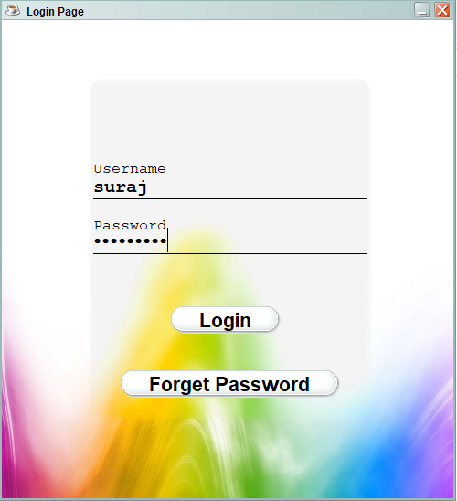

**2. Homepage** 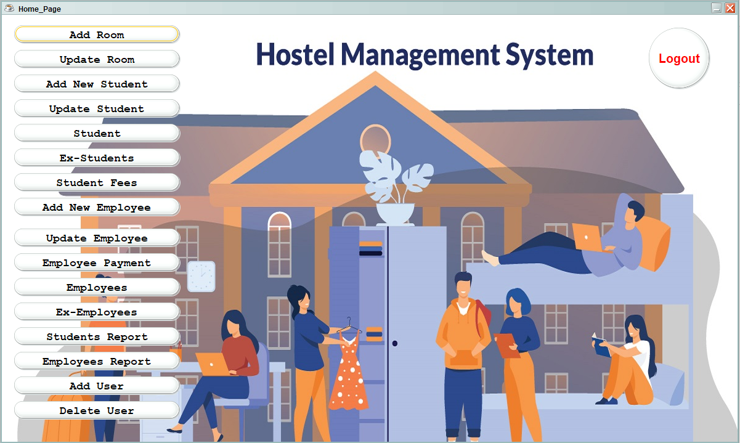

**3. Add Rooms**

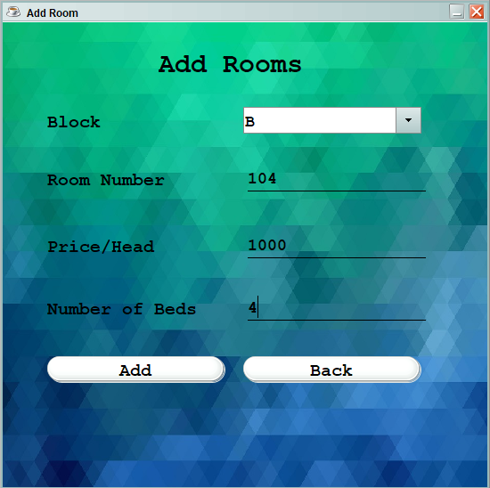

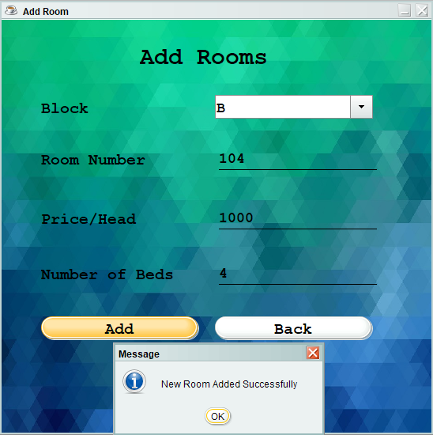

**4. Update Room**

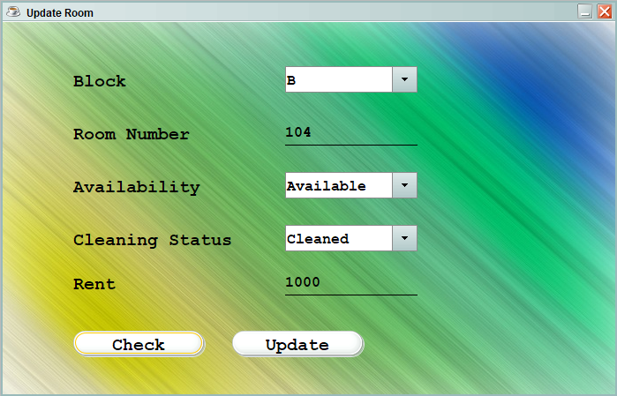

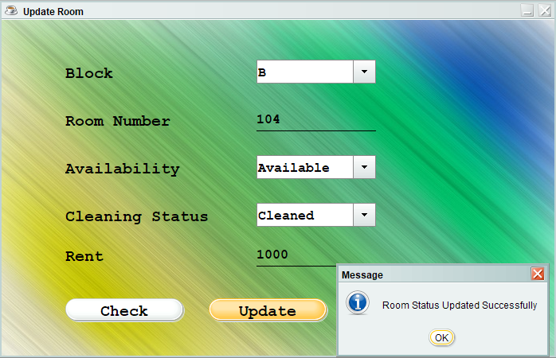

**5. Add Student**

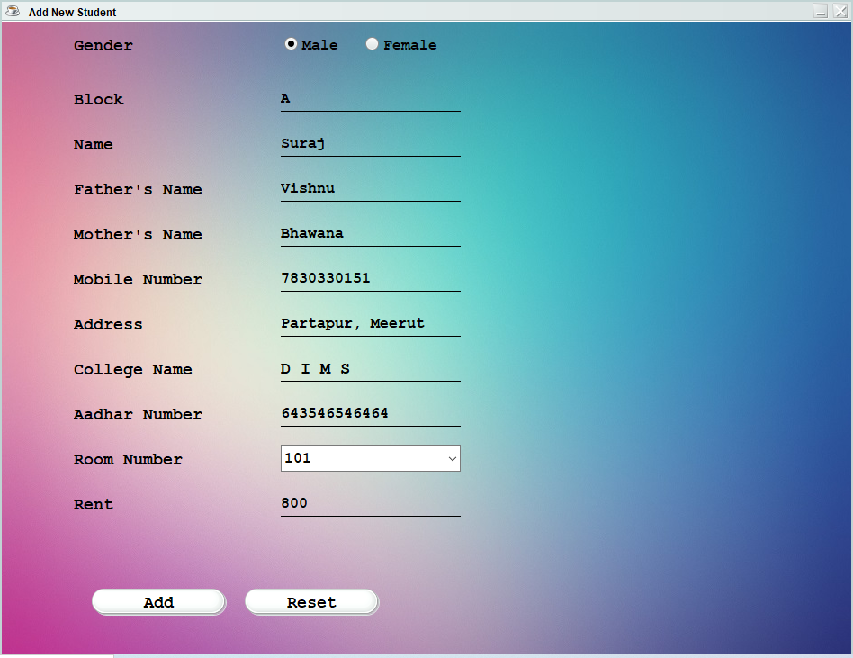

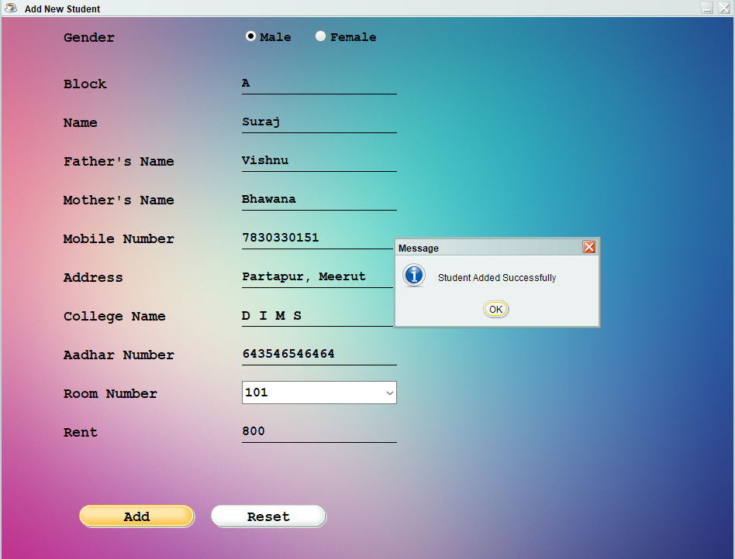

**6. Update Students**

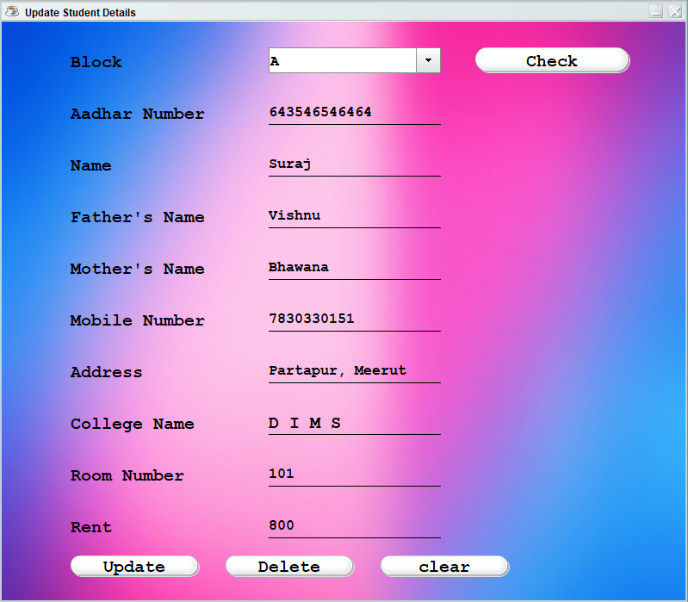

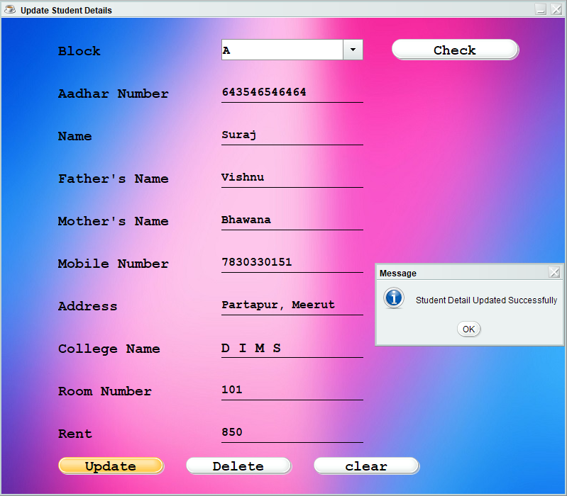

**7. Student Details**

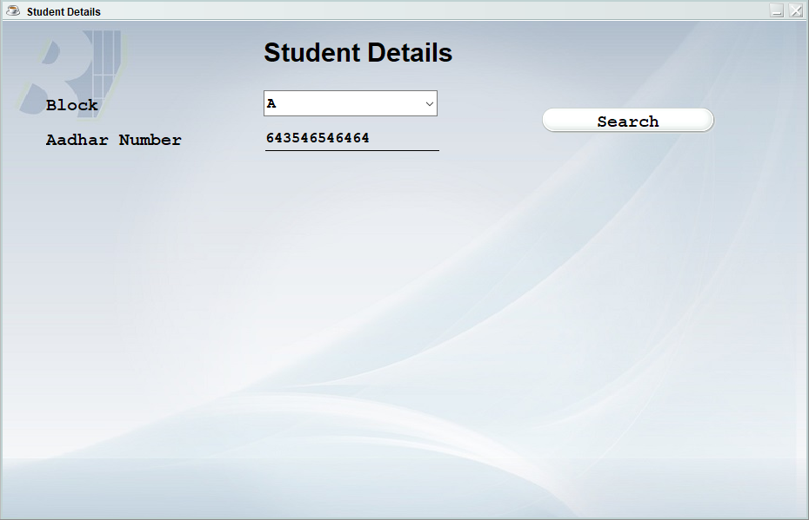

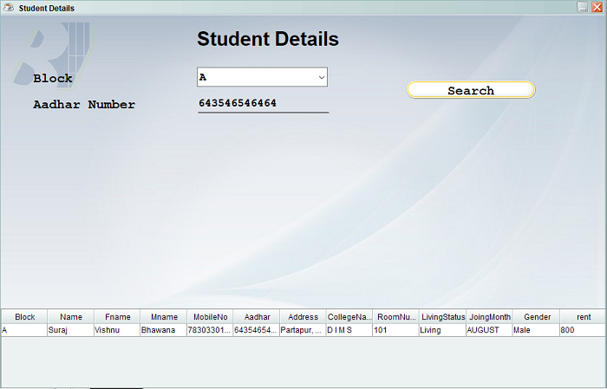

**8. Ex-Student Details**

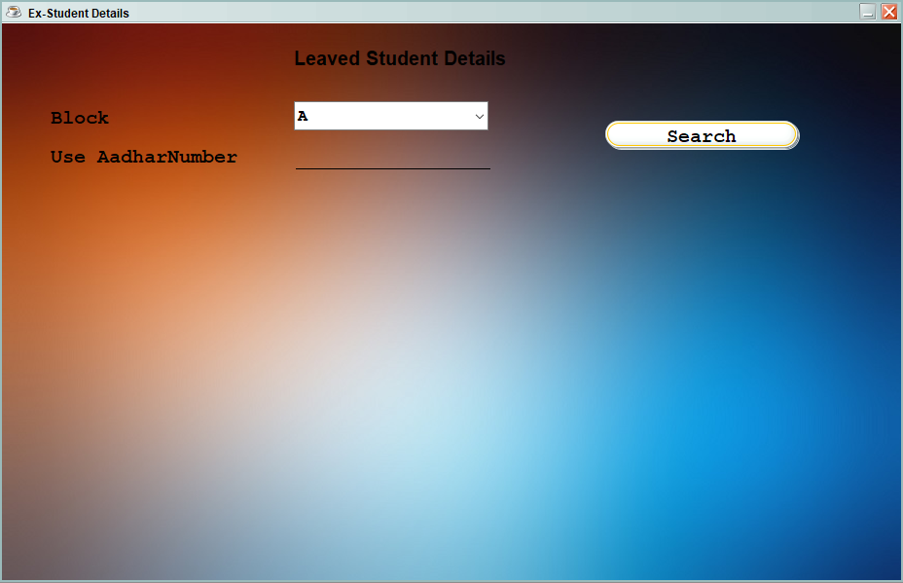

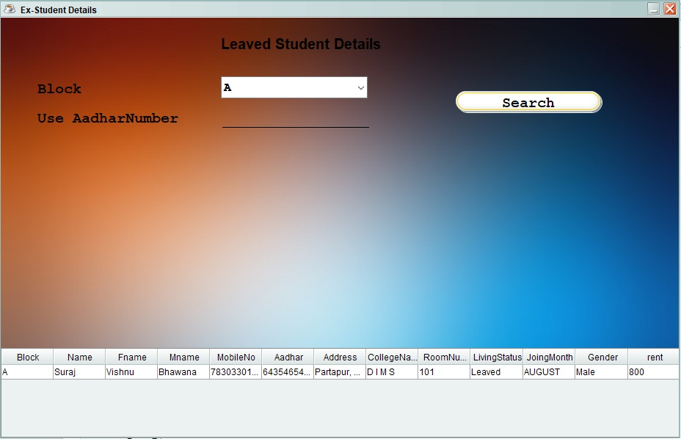

**9. Student Rent**

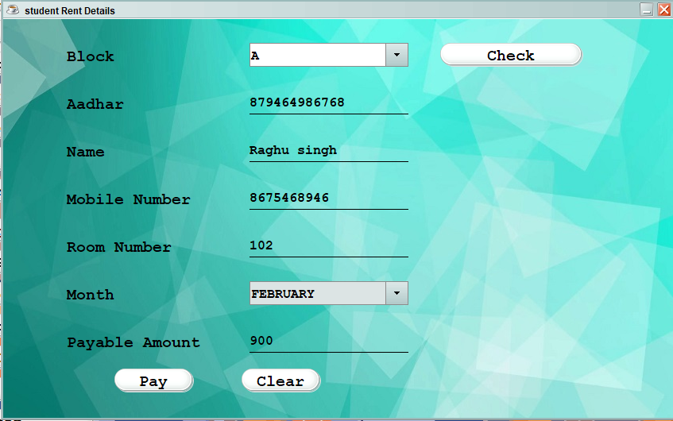

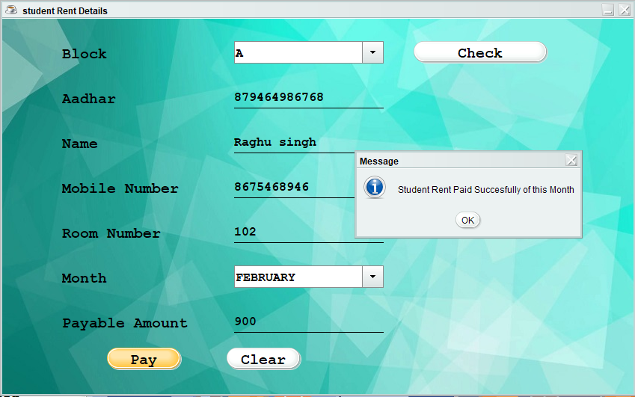

**10. Add Employee**

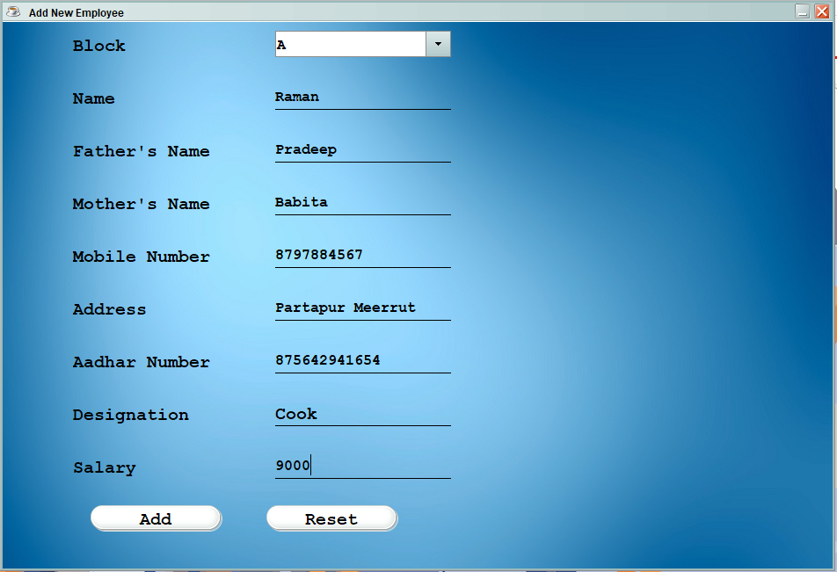

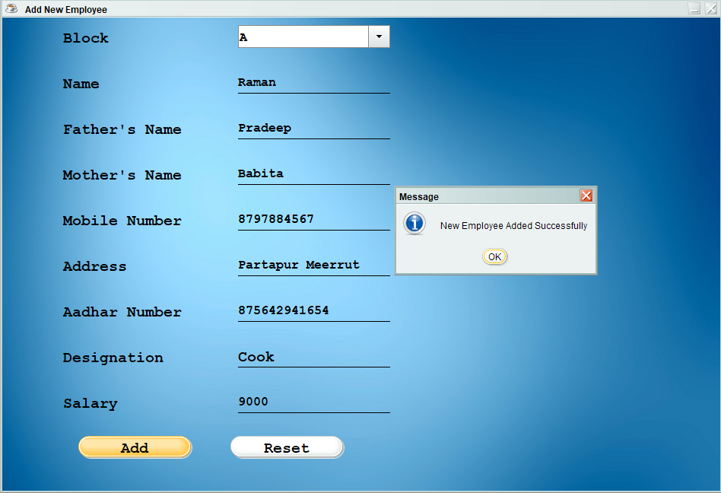

**11. Updete Employee**

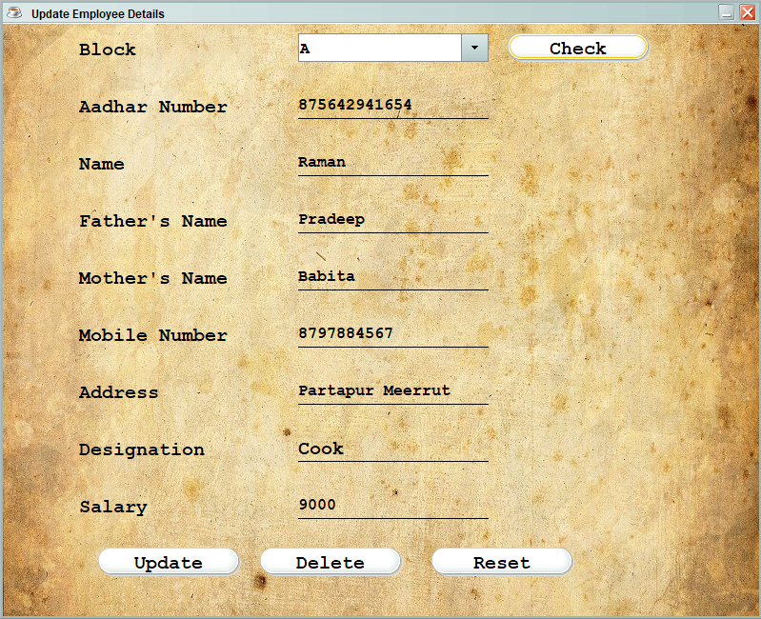

**12. Employee Payment**

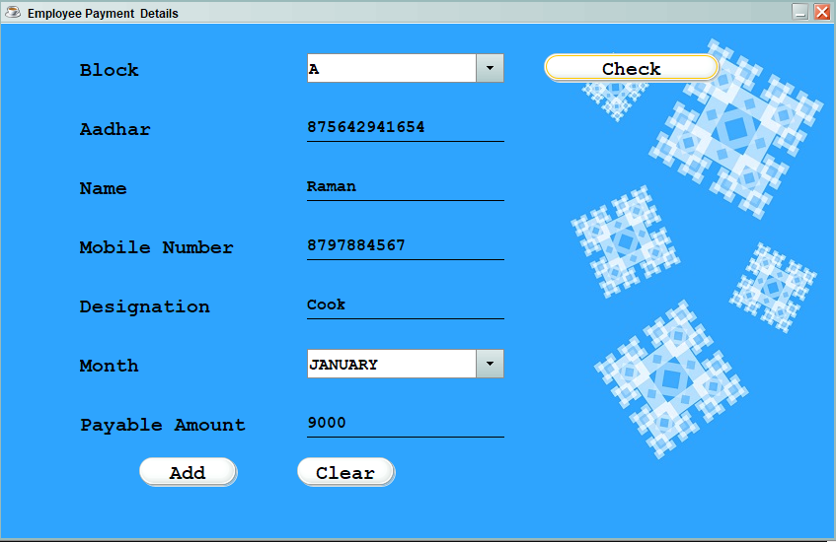

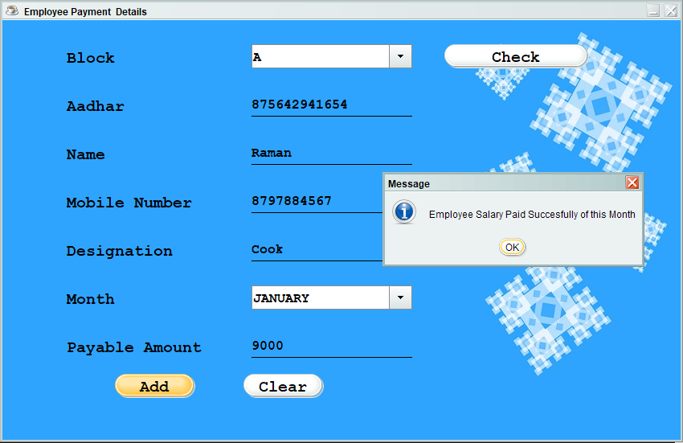

**13. Employee Details**

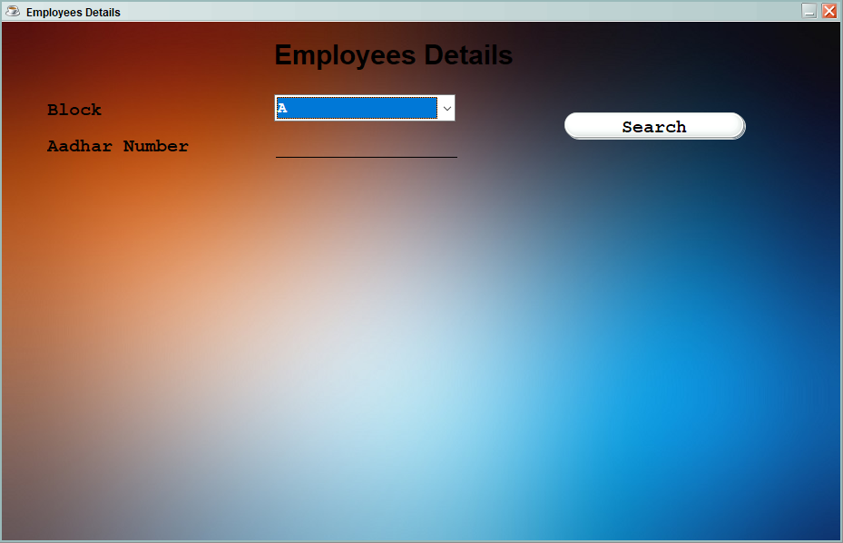

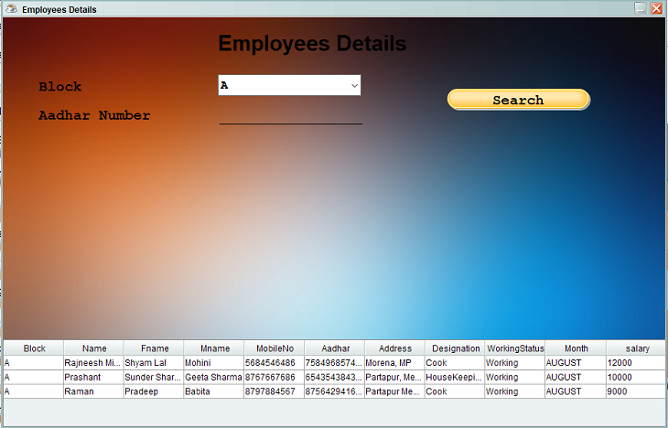

**14. Ex-Employees**

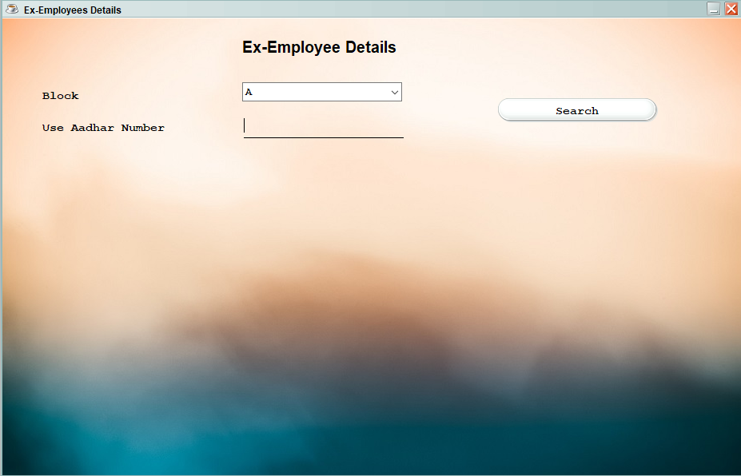

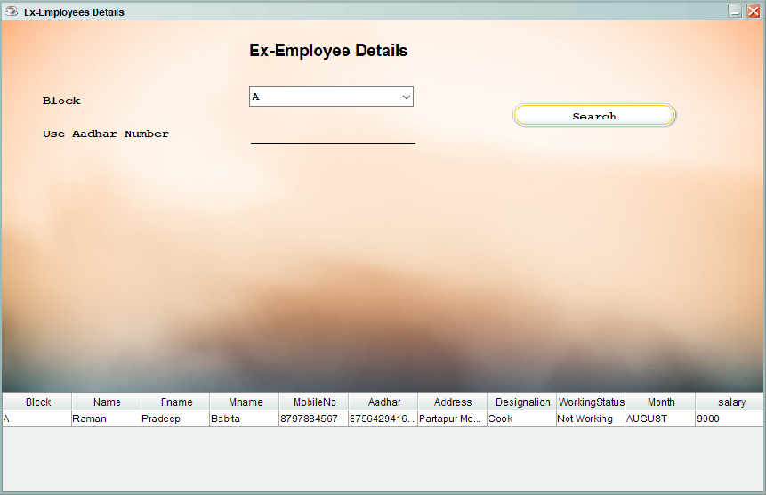

**15. Student Report**

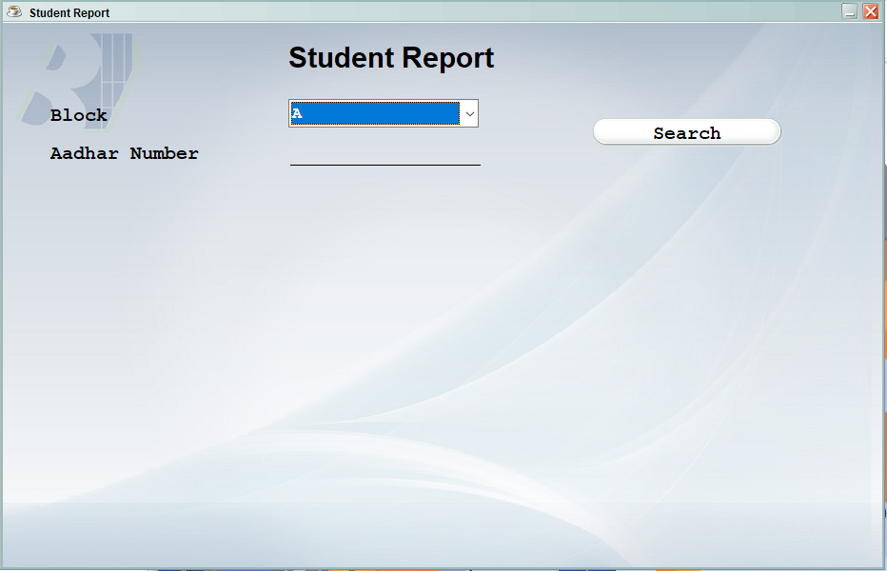

**16. Employee Report**

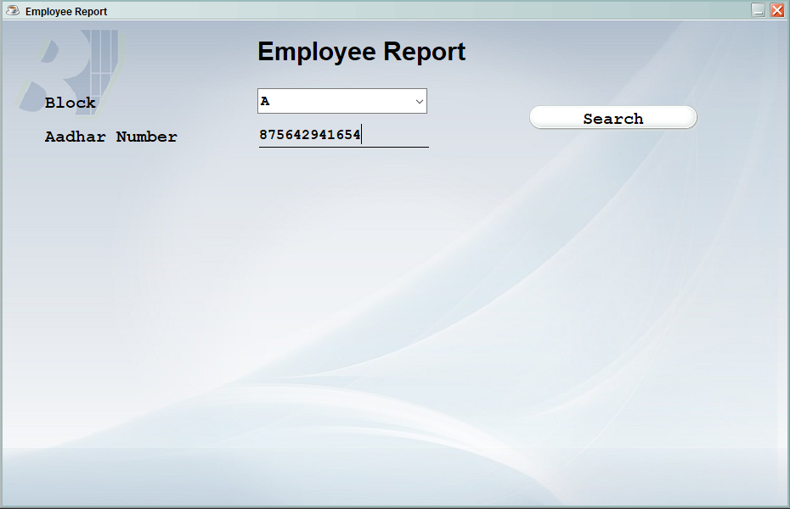

**17. Add user**

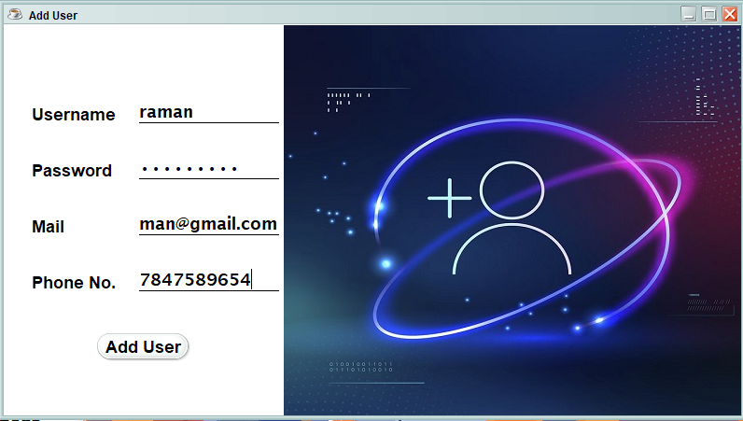

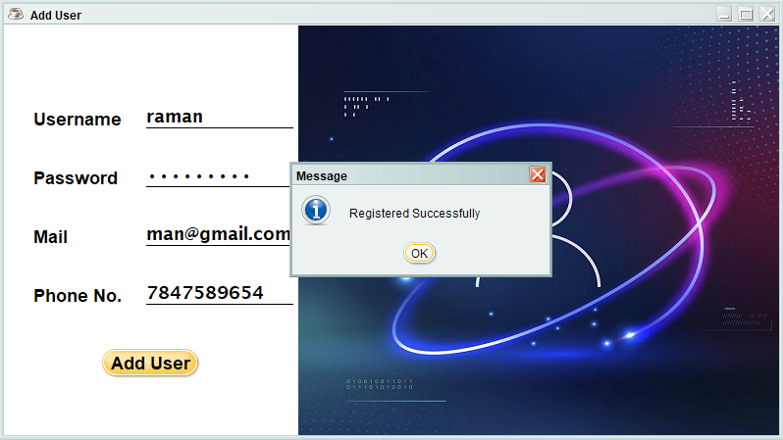

**18. Delete User**

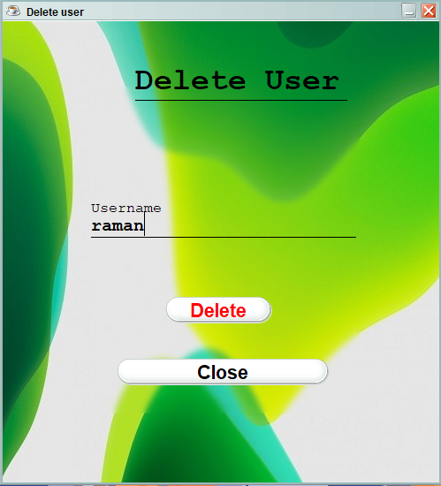

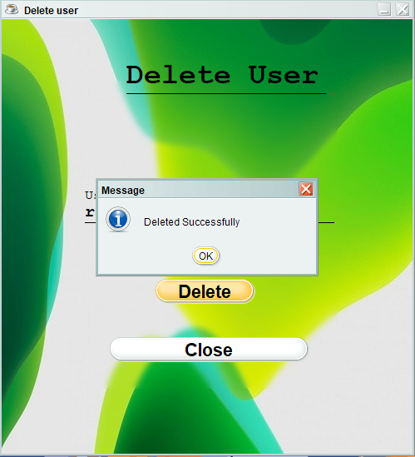

## TESTING

During systems testing, the system is used experimentally to ensure that the software does not fail. In other words, we can say that it will run according to its specifications and in the way users expect. Special test data are input for processing, and the results examined. A limited number of users may be allowed to use the system so that analyst can see whether they try to use it in unforeseen ways. It is desirable to discover any surprises before the organization implements the system and depends on it.

Software modules are tested for their functionality as per the requirements identified during the requirements analysis phase. To test the functionality of the file transfer and chat application, a Quality Assurance (QA) team is formed. The requirements identified during the requirements analysis phase are submitted to the QA team. In this phase the QA team tests the application for these requirements. The development team submits a test case report to the QA team so that the application can be tested in the various possible scenarios.

## The software development project, errors can be injected at any stage during development i.e. if there is an error injected in the design phase then it can be detected in the coding phase because there is the product to be executed ultimately on the machine, so we employ a testing process.

During the testing the program to be tested is executed with certain test cases and output of these test cases is evaluated to check the correctness of the program. It is the testing that performs first step in determining the errors in the program.

# Test Cases and Test Criteria

During Test Cases that are good at revealing the presence of faults is central to successful testing. The reason for this is that if there is a fault in the program, the program can still provide the expected behavior on the certain inputs. Only for the set of inputs the faults that exercise the fault in the program will the output of the program devise from the expected behavior. Hence, it is fair to say that testing is as good as its test case.

The number of test cases used to determine errors in the program should be minimum. There are two fundamental goals of a practical testing activity:-

* maximize the number of errors detected and.
* minimize the number of test cases.

As these two goals are contradictory so the problem of selecting test cases is a complex one. While selecting the test cases the primary objective is to ensure that if there is an error or fault in the program, it is exercised by one of its test cases. An ideal test case is one which succeeds (meaning that there are no errors, revealed in its execution) only it there are no errors in the program one possible set of ideal test cases is one which includes all the possible inputs to the program. This is often called "exhaustive testing", however it is impractical and infeasible as even a small program can have an infinite input domain.

So to avoid this problem we use "test criteria" in selection of the test cases. There are two aspects of the test case selection:-

* specifying a criteria for evaluating the test cases
* generating the set of cases that satisfy a given criteria.

The fully automated process of generating test criteria has not been yet found rather guidelines are only the automated tool available to us previously. The two fundamental properties for a testing criterion are:-

* **Reliability**: a criterion is reliable if all the sets that satisfy the criteria detect the same error. .
* **Validity**: a criterion is valid if for any error in the program there is some set satisfying the criteria that will reveal the error.

The fundamental theorem of testing is that if a testing criterion is valid and reliable, if a set satisfying criteria succeeds then the program contains no errors.

**Approaches to Testing**

There are two fundamental approaches to testing they are:

**Functional Testing/Black Box Testing**:

In functional testing the structure of the program is not considered. Test cases are solely determined on the basis of requirement or specification of the program or module. Internals of the modules and the programs are not considered for selection of test cases. Due to this nature it is also called "black box testing".

The most obvious functional testing procedure is "exhaustive testing", which is impractical.

The other criteria for generating the test case are to generate them "randomly" this strategy has a little chance of resulting in a test case that is close to optimal.

There is no appropriate criterion for developing the test case so we have certain heuristic approaches-:

a) **Equivalence Class Partitioning**: in which the domain of all inputs is divided into a set of equivalence classes, so that if any test in that class succeeds, then every test in that class will succeed i.e. the success of one set element implies the success of the other.

b) **Boundary Value Analysis**: It has been observed that programs work correctly for a set of values in an equivalence class fail on certain values. These values generally lie on the boundary of equivalence class. So in the boundary value analysis we chose an input for a test case from an equivalence class, such that input lies on the edge of equivalence class. Boundary value test cases are also called "extreme cases".

c) **Cause-Effect Graphing**: The problem with the prior approaches is that they consider each input separately i.e. both concentrate on classes and conditions of one input. The combination of inputs is not considered which is used in many cases. One way to exercise the combination of various input conditions is to consider all the valid combinations of the equivalence class of the input conditions. The technique starts with identifying the causes and the effect of system under testing.

**Structural Testing**:

In the structural approach the test cases are generated an the basis of the actual code of the program or the module to be tested, This structural approach is sometimes called "glass box testing", This testing is concerned with the implementation of the program. The content is not to exercise the various input conditions rather different programming structures and data structures used in the program.

There are three different approaches to structural testing they are- :

1. **Control flow based criteria**:

Most common structure based criteria use control flow based testing in which the control flow graph of the program is considered and coverage of various aspects of graph are specified as criteria. The various control flow based strategies are

* statement coverage,
* branch coverage and
* all path coverage

b) **Data Flow based testing:**

The basic idea behind the data flow based testing is to make sure that during testing, the definitions of variables and their subsequent use is tested. To implement the data flow based testing the data flow graph is first made from the control flow graph.

1. **Mutation Testing:**

In the above two testing techniques the focus is on which path to be executed, but mutation testing is not a path-based approach. The mutation testing requires that the set of test cases must be such that they can distinguish between the original programs and is mutants. In software world there is no fault model as in hardware so most of the techniques do guess work regarding where the fault must lie and then select the test cases to reveal those faults. In Mutation testing faults of some pre-decided types are introduced in the program being tested. Then those faults are found in the mutants.

**Future Scope of the Project**

The Purpose of this Hostel Management system is to ease hostel management system and create a convenient application.It tracks all the details about the Hostel,Rooms,Payments. This Project is created for the Hostels which find difficulties in manual data entry because This is created to reduce the manual work for managing the rent ,students,beds even the employees working in the Hostel

With adding, deleting and even updating employee as well as students .

**Bibliography**

1. **W3Schools. "Java Tutorial." W3Schools.com,**

<https://www.w3schools.com/java/default.asp>. Accessed 19 Feb. 2023. W3Schools is a well-known online learning platform that offers tutorials and reference materials for a wide range of programming languages, including Java.

1. **JavaWorld. "Java Tutorials." JavaWorld.com,**

<https://www.javaworld.com/category/java-tutorials/>. Accessed 19 Feb. 2023. JavaWorld is a long-running online publication focused on Java development. This website offers a wide range of tutorials, articles, and tips for Java developers, covering topics such as GUI programming, 150150concurrency, and security.

1. **Stack Overflow. "Java Questions and Answers."**

**StackOverflow.com,**<https://stackoverflow.com/questions/tagged/java>. Accessed 19 Feb. 2023. Stack Overflow is a popular Q&A community for programmers. This link takes you to a list of Java-related questions and answers on Stack Overflow, which can be a valuable resource for troubleshooting issues and learning from other developers' experiences.